
BIJU PATNAIK INSTITUTE OF INFORMATION TECHNOLOGY & MANAGEMENT STUDIES (BIITM), BHUBANESWAR

Plot No. F/4, Chandaka Industrial Estate, Infocity, Patia, Bhubaneswar-24

SUMMER INTERNSHIP PROJECT 2025

REPORT TITLE
Ms Soumya Mohapatra
Asst. Prof (HR) BIITM Bhubaneswar

Mr. Ajayanada Sahoo Sahoo
HR Manager
Mahindra Aditya Motors
To Study The Recruitment & Selection Process At Mahindra Aditya motors
Corporate Guide
Faculty Guide

Sanobar Akhtar
MBA Batch: 2024-26
University Regn. No.: 2406258185

SUBMITTED BY



CERTIFICATE OF FACULTY/INTERNAL GUIDE

This is to certify that Ms Sanobar Akhtar, bearing university registration no 2406258185 of 2024-26 batch, has completed her summer internship at Mahindra Aditya Motors
(organization name) from 9TH June 25 to 25TH July 25 under the supervision of Mr. Ajayanada Sahoo (corporate guide) and has submitted this project report under my guidance in partial fulfilment of the requirements for award of the degree of Master of Business Administration at Biju Patnaik Institute of Information Technology and Management Studies, Bhubaneswar. To the best of my knowledge and belief, this project report has been prepared by the student and has not been submitted to any other institute or university for the award of any degree or diploma.

Date: Signature of the Faculty/Internal Guide
Place: Bhubaneswar Name:
Designation:

Guide

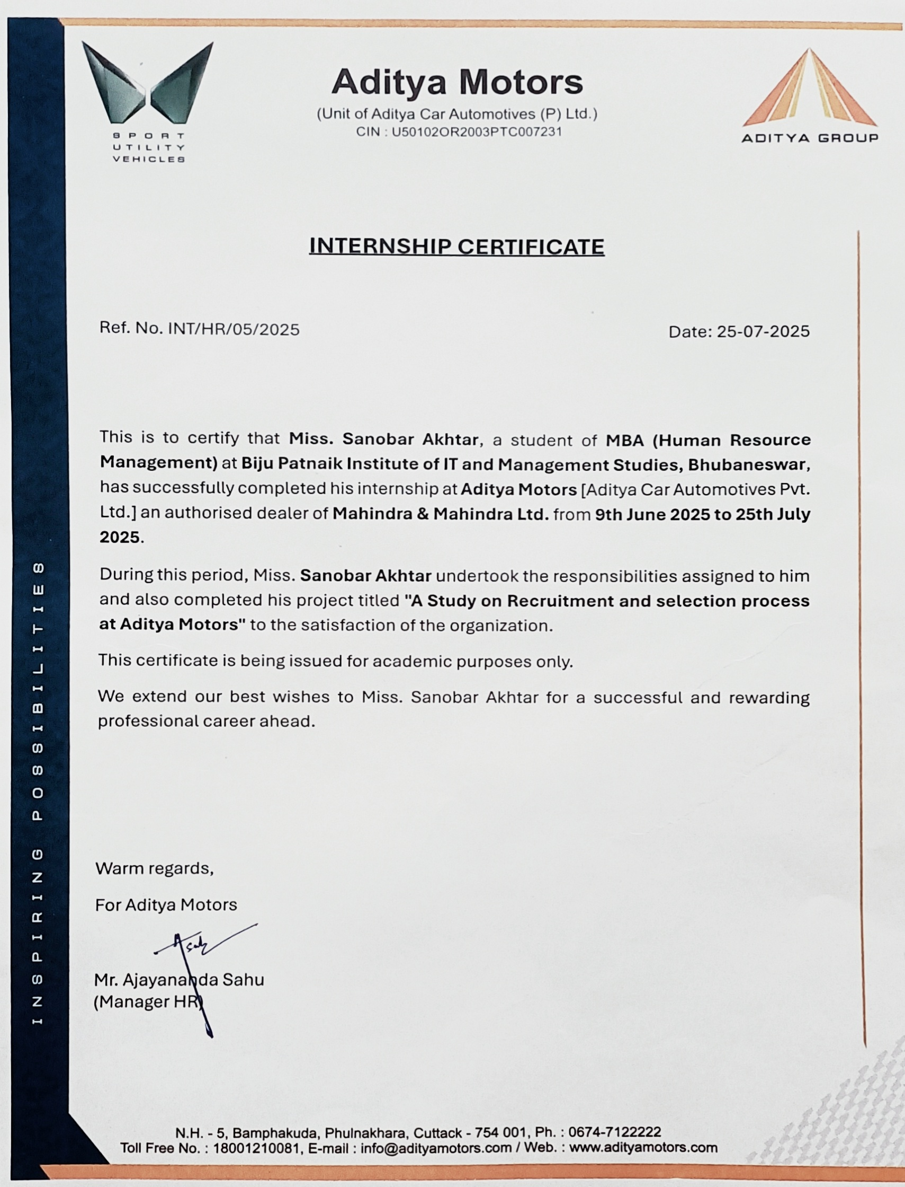
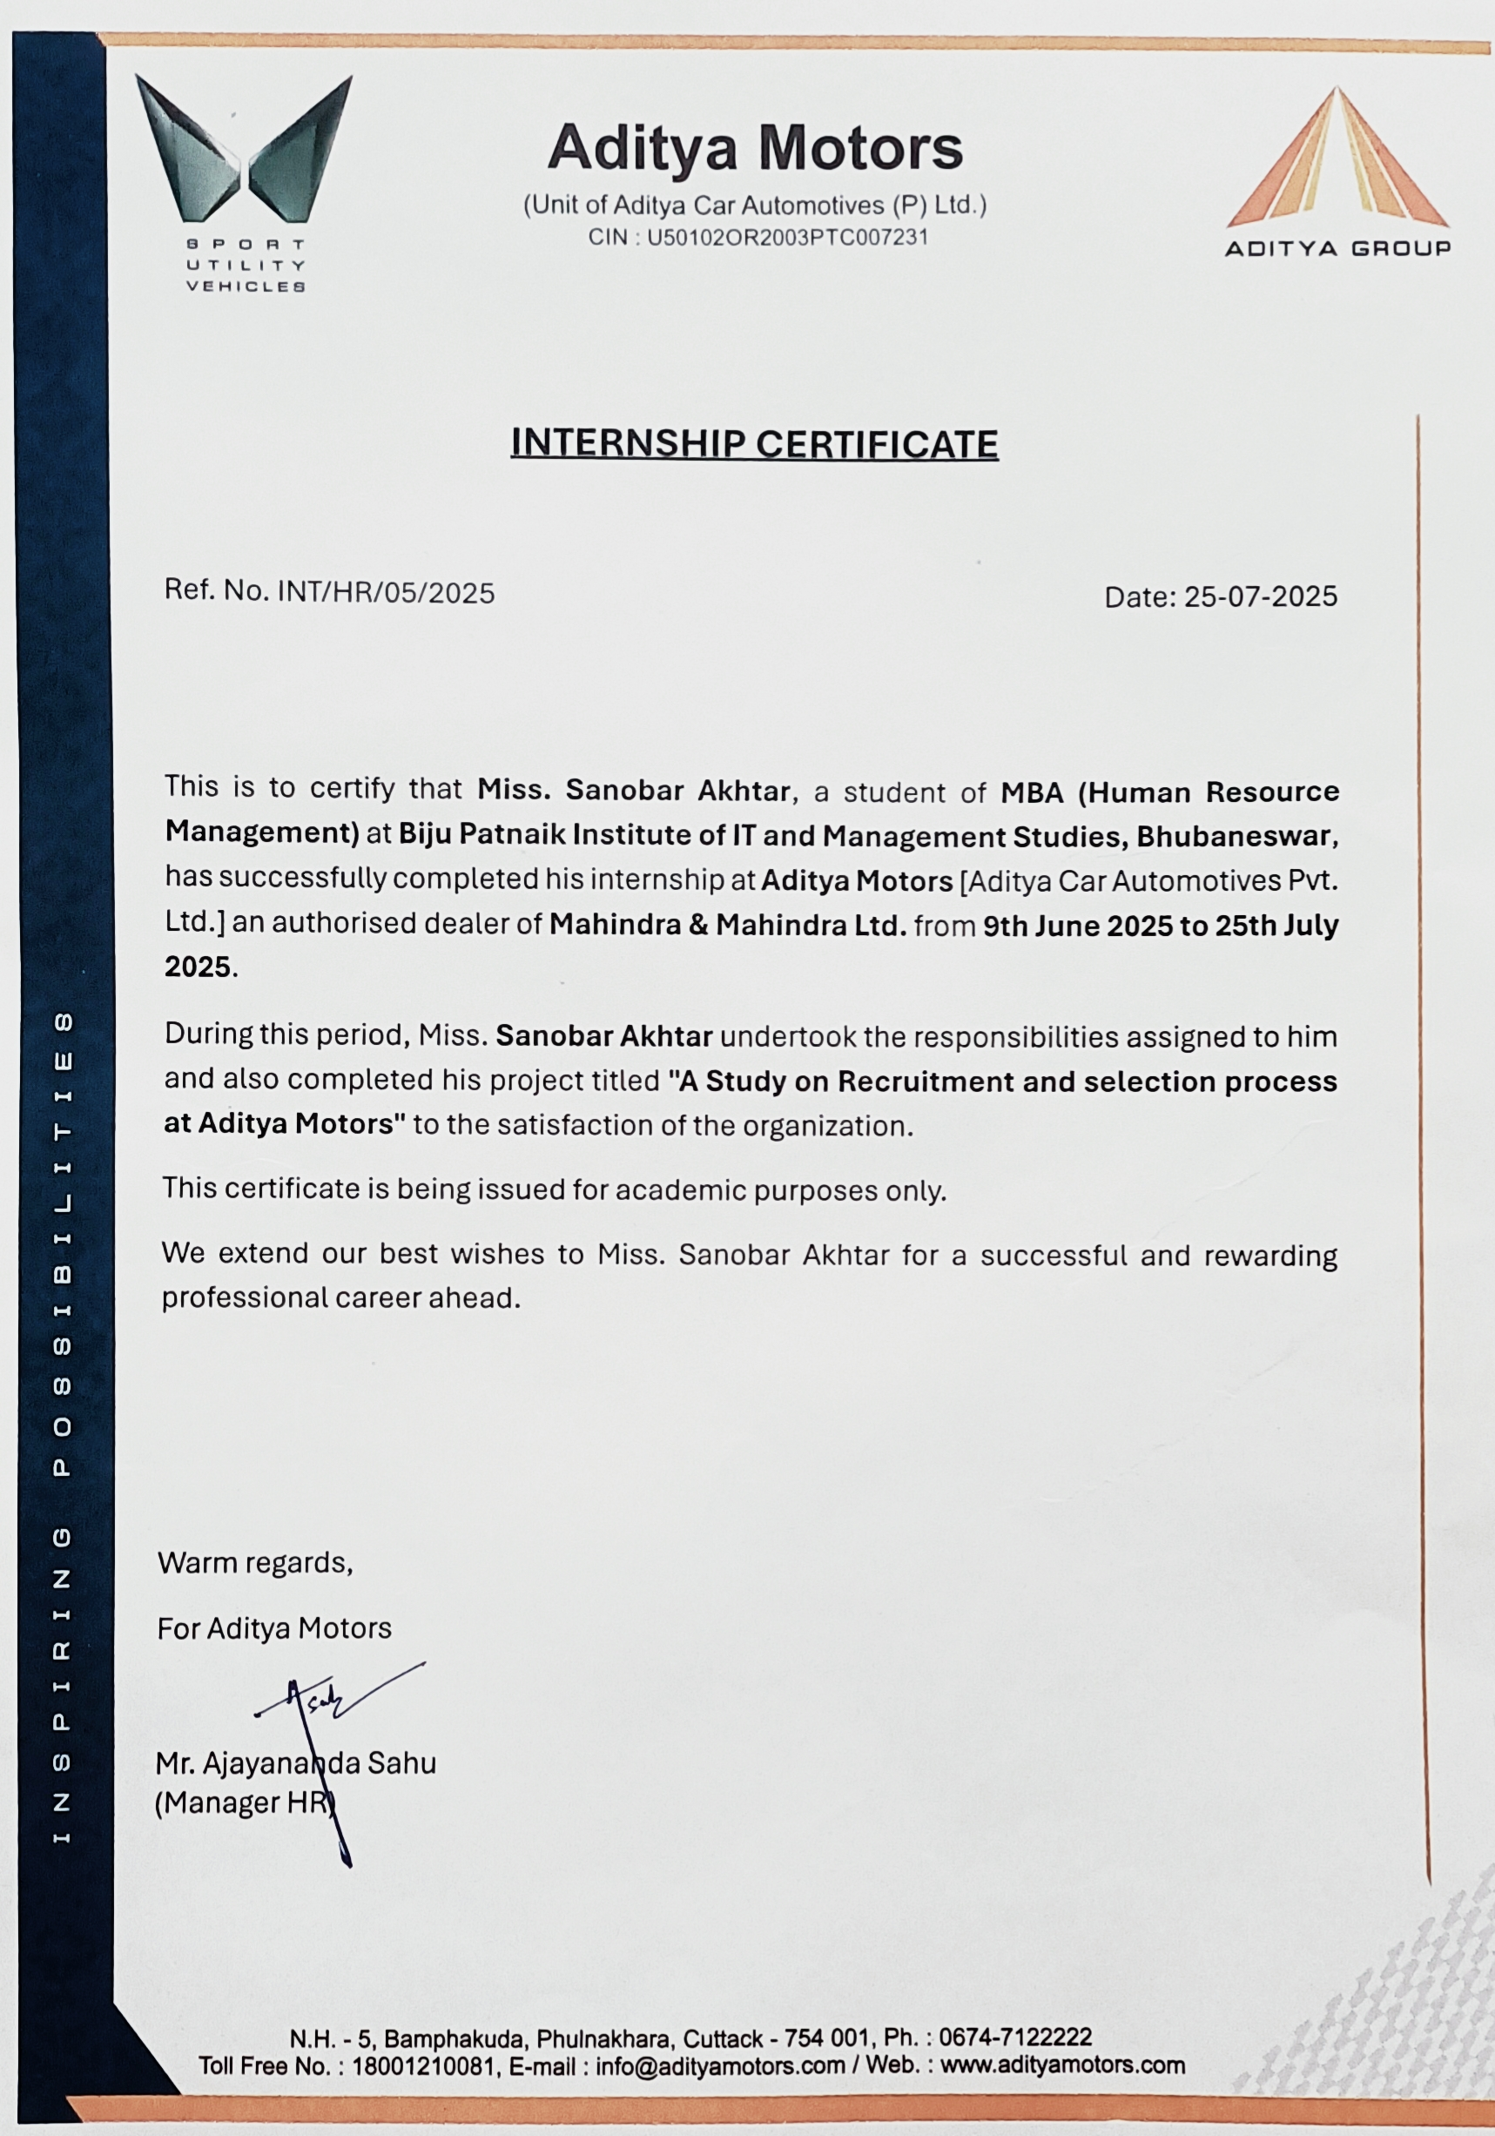
DECLARATION

I, Ms Sanobar Akhtar Bearing university registration no 2406258185 (2024-26 batch), hereby declare that the project report titled Recruitment & Selection Process
is based on my internship at Mahindra Aditya Motors (organization name), during the period 9TH June 25 to 25TH July 25 and is an original work done by me under the supervision of Mr Ajayanada Sahoo (Corporate Guide) and Prof. Soumya Mohapatra (Internal Guide). This report is being submitted to Biju Patnaik Institute of Information Technology and Management Studies, Bhubaneswar, affiliated to Biju Patnaik University of Technology, Odisha, in partial fulfilment of the requirements for the award of the degree of Master of Business Administration. This project report has not been submitted to any other institute/university for the award of any degree or diploma.

Date:
Place: Signature
ABSTRACT

Recruitment and selection are critical human resource management functions that significantly influence organizational performance and competitiveness. Recruitment refers to the systematic process of attracting, identifying, and encouraging potential candidates to apply for available positions, while selection involves evaluating and choosing the most suitable individuals to meet organizational needs. An effective recruitment and selection strategy ensures that the right talent is matched with the right role, thereby reducing turnover, enhancing productivity, and fostering long-term growth. Modern organizations increasingly integrate technology, data-driven assessments, and competency-based approaches into these processes to improve efficiency and fairness. Furthermore, ethical considerations, diversity, and inclusivity play an essential role in shaping recruitment and selection practices in today’s globalized work environment. Ultimately, recruitment and selection are not merely administrative tasks but strategic drivers that align human capital with organizational goals.

TABLE OF CONTENTS

Sr. | particular | Page No.
 | Certificate | 02-03
 | DECLARATION | 04
 | ABSTRACT | 05
1. | Introduction of company | 06
2. | Introduction to the study | 07-10
 | Background of the study
 | Importance of the study
 | Origin of the report
 | Limitation of the study
 | Objective , need & scope
3. | Introduction to the topic | 11-32
 | Recruitment and selection process
4. | Research methodology | 33-38
 | Research design
 | Data collection
5. | Data analysis & Interpretation | 39-47
6. | Finding Conclusion & Recommendation | 48-56
 | Suggestions
 | Bibliography
 | References
 | Annexure

COMPANY INTRODUCTION

ADITYA MOTORS (A Unit of Aditya Car Automotives Pvt. Ltd) is the Authorised Dealer of all Range of Mahindra Vehicles, with huge infrastructure. A showroom integrated with an after-sales service facility featuring 4S facilities (Sales, Service, Spare Parts and Business Systems) to ensure that customers receive best-in- class pre and post sales ownership experience.
It is situated on the midway of Cuttack-Bhubaneswar-N.H.5.The Showroom is rated as one of the biggest showrooms in the continent overing an area around 1,26,000 Sqft.The Showroom displays up to 14 cars in an urban street display style.The Workshop is well equipped with modern and sophisticated machines. The workshop has 59 service bays and quick Service bays that can service up to 124 vehicles per day.
To provide exceptional and personalized service to our customers while maintaining the highest level of professionalism, integrity and ethics in everything we do.
Our vision is to deliver complete customer satisfaction in all areas of business through our passion, continuous innovation and development of State-of-the-art Infrastructure. We strive to continuously improve our operations and refine our offerings to meet the evolving needs and preferences of our customer while maintaining the highest evel of ethical and professional standards.
Mahindra offers a wide range of service solutions designed to enhance customer satisfaction and vehicle performance. Through its dedicated after-sales support, the company provides regular maintenance, repairs, and genuine spare parts across an extensive service network. Its digital platform, Mahindra With You Hamesha, allows customers to book services, track service history, and receive timely updates. Additional offerings such as roadside assistance, doorstep service, pick-and-drop facilities, and extended warranty plans ensure maximum convenience and peace of mind. Backed by skilled technicians and a focus on transparency and quality, Mahindra’s service experience reflects its strong commitment to customer care.

CHAPTER- 2

INTRODUCTION

TO

THE

STUDY

- INTRODUCTION TO THE SUBJECT :

  - Introduction: In Human Resources Management cycle as well as in any organization recruitment and selection plays an important and vital role in achieving the organizational vision, mission goals and objectives. Recruitment and selection is the critical resource of the organization which is the staffing function. The primary goal of staffing is to get the right people for the company to operate effectively and efficiently. Before recruitment and selection we have to analyze the external environment and examine its internal situation to develop human resource plans considering any new requirement and existing vacant positions. Getting the right people interested in applying for a job at a company is the core of recruitment.
All recruitment and selection should be based on organization‟s approved human resources plan. HRM department should assist line managers to develop their human resource plans effectively. Based on the recruitment information from all units, HRM department must analyze human resource plans of different units and develop a master plan for the organization. To conduct recruitment efficiently, it is better to split the recruitment in month order, HRM department should process the recruitment after checking with budget provision and final approval from the top management.

  - Background of The study: It is important to have a well defined recruitment policy in place, which can be executed effectively to get the best fits for the vacant positions. Selecting the wrong candidate or rejecting the right candidate could turn out to be costly mistakes for the organization.

  - Importance of the Study: A misfit who is not in tune with the organization‟s philosophies and goals can damage production, customer satisfaction, relationship with suppliers and the overall quality or work. He can also adversely affect the morale and commitment of co-works and negate efforts to foster team work. Training way out of a wrong hire can be very expensive.

  - Origin of the Report: Miss Anuradha , Faculty Member, NIILM University assigned this internship report to me as a part of the BBA program in Toyoda Gosei Minda Pvt.Ltd. This report is originated as the practical fulfillment on my BBA degree and the topic is “Recruitment and Selection Process at Toyoda Gosei.

  - Limitations of the Study:

There are some limitations in my study; I faced some problems during the study, which are given below:

    - Lack of time: The time period for this study was very short. I had only 7 weeks in my hand to complete this report, which was not enough. so, I could not go in depth analysis, Sometimes the officials were busy and were not able to give much time.
    - Insufficient date: Some desired information could not be collected due to confidentially of business.

    - Lack of Supervision: Few officials sometimes felt disturbed, as they were busy with their tasks, Sometimes, they didn‟t want to supervise due to pressure of work load.
    - Other Limitations: I was single person who collected all data. But it should be a group study. So, it was very much difficult for me to gather all the information.

  - OBJECTIVE NEED & SCOPE :
1.6.1 Objectives of the Study:
- .To study the recruitment and selection process in Mahindra Aditya motors.
- To study the recruitment procedures for executive trainees.
- To take feedback of the executive trainees on the mode of recruitment.

1.6.2 Need of the Study
Mahindra Aditya motors is doing a lot of retrenchment these days and employees are suffering from a lot of stress these days and are highly dissatisfied with their job. Research says that Emotional Intelligence helps to reduce stress by 66%.So by this study I will be able to find that whether there is any correlation between Emotional Intelligence and Job Satisfaction and if there exists a coo relation than how company can use it to enhance the performance of employees.

.1.6.3 Scope of study
This proposed study is being limited to Mahindra Aditya motors, Neemrana . This proposed study will help to find the Recruitment and Selection Process of the Organization.

CHAPTER- 3

RECRUITMENT

AND

SELECTION PROCESS

INTRODUCTION:
Human resource is an important corporate asset and the overall performance of company depends on the way it is put to use. In order to realize company objectives, it is essential to recruit people with requisite skills, qualification and experience. While doing so we need to keep present and future requirements of company in mind.
Successful recruitment methods include a thorough analysis of the job and the labour market conditions. Recruitment is almost central to any management process and failure in recruitment can create difficulties for any company including an adverse effect on its profitability and inappropriate levels of staffing or skills. Inadequate recruitment can lead to labour shortages, or problems in management decision making.
Recruitment is however not just a simple selection process but also requires management decision making and extensive planning to employ the most suitable manpower. Competition among business organizations for recruiting the best potential has increased focus on innovation, and management decision making and the selectors aim to recruit only the best candidates who would suit the corporate culture, ethics and climate specific to the organization.
The process of recruitment does not however end with application and selection of the right people but involves maintaining and retaining the employees chosen. Despite a well drawn plan on recruitment and selection and involvement of qualified management team, recruitment processes followed by companies can face significant obstacles in implementation. Theories of HRM may provide insights on the best approaches to recruitment although companies will have to use their in house management skills to apply generic theories within specific organizational contexts.

2.1 RECRUITMENT
Recruitment is defined as, “a process to discover the sources of manpower to meet the requirements of the staffing schedule and to employ effective measures for attracting that manpower in adequate numbers to facilitate effective selection of an efficient workforce.”
Edwin B. Flippo defined recruitment as “the process of searching for prospective employees and stimulating them to apply for jobs in the organization.” In simple words recruitment can be defined as a „linking function‟-joining together those with jobs to fill and those seeking jobs.

PURPOSE AND IMPORTANCE
The general purpose of recruitment is to provide a pool of potentially qualified job candidates.
Specifically, the purposes and needs are:
- Determine the present and future requirements of the organization in conjunction with its personnel-planning and job-analysis activities.
- Increase the pool of job candidates at minimum cost.
- Help increase the success rate of the selection process by reducing the number of visibly, under qualified or overqualified job applicants.
- Help reduce the probability that job applicants, once recruited and selected, will leave the organization only after a short period of time
- Begin identifying and preparing potential job applicants who will be appropriate candidates.
- Induct outsiders with a new perspective to lead the company.
- Infuse fresh blood at all levels of the organization.
- Develop an organizational culture that attracts competent people to the company.
- Search for talent globally and not just within the company.

RECRUITMENT PROCESS :
The recruitment and selection is the major function of the human resource department and recruitment process is the first step towards creating the competitive strength and the strategic advantage for the organizations. Recruitment process involves a systematic procedure from sourcing the candidates to arranging and conducting the interviews and requires many resources and time.

A general recruitment process is as follows:

Identifying the vacancy:
The recruitment process begins with the human resource department receiving requisitions for recruitment from any department of the company. These contain:
- Posts to be filled
- Number of persons
- Duties to be performed
- Qualifications required
  - Preparing the job description and person specification.

  - Locating and developing the sources of required number and type of employees (Advertising etc).

  - Short-listing and identifying the prospective employee with required characteristics.

  - Arranging the interviews with the selected candidates.

  - Conducting the interview and decision making

The recruitment process is immediately followed by the selection process i.e. the final interviews and the decision making, conveying the decision and the appointment formalities.

FACTORS AFFECTING RECRUITMENT
The following are the 2 important factors affecting Recruitment:
1. Internal Factors:
- Recruiting policy
- Temporary and part-time employees • Recruitment of local citizens
- Engagement of the company in HRP
- Company‟s size
- Cost of recruitment
- Company‟s growth and expansion

2. External Factors:
- Supply and Demand factors
- Unemployment Rate
- Labour-market conditions
- Political and legal considerations
- Social factors
- Economic factors
- Technological factors

SOURCES OF RECRUITMENT
The sources of recruitment may be broadly divided into two categories: internal sources and external sources. Both have their own merits and demerits.

METHODS OF RECRUITMENT
Internal Methods:
- Promotions and Transfers: This is a method of filling vacancies from internal resources of the company to achieve optimum utilization of a staff members skills and talents. Transfer is the permanent lateral movement of an employee from one position to another position in the same or another job class assigned to usually same salary range. Promotion, on the other hand is the permanent movement of a staff member from a position in one job class to a position in another job class of increased responsibility or complexity of duties and in a higher salary range.
- Job Posting: Job Posting is an arrangement in which a firm internally posts a list of open positions (with their descriptions and requirements) so that the existing employees who wish to move to different functional areas may apply. It is also known as Job bidding. It helps the qualified employees working in the organization to scale new heights, instead of looking for better perspectives outside. It also helps organization to retain its experienced and promising employees.
- Employee Referrals: It is a recruitment method in which the current employees are encouraged and rewarded for introducing suitable recruits from among the people they know. The logic behind employee referral is that “it takes one to know one”.

Benefits of this method are as follows:
- Quality Candidates
- Cost savings
- Faster recruitment cycles
- Incentives to current employees
On the other hand it is important for an organization to ensure that nepotism or favoritism does not happen, and that such aspects do not make inroads into the recruitment process.
External Methods:
External methods of recruitment are again divided into two categories-
Direct External Recruitment Methods
1. Campus Recruitment In Campus Recruitment, Companies / Corporate visit some of the most important Technical and Professional Institutes in an attempt to hire young intelligent and smart students at source. It is common practice for Institutes today to hire a Placement Officer who coordinates with small, medium and large sized Companies and helps in streamlining the entire Campus Recruitment procedure.
Benefits of Campus Recruitment
- Companies get the opportunity to choose from and select the best talent in a short span of time.
- Companies end up saving a lot of time and efforts that go in advertising vacancies, screening and eventually selecting applicants for employment.
- College students who are just passing out get the opportunity to present themselves to some of the best companies within their industry of interest. Landing a job offer while still in college and joining just after graduating is definitely what all students dream of. On the negative front, campus recruiting means hiring people with little or no work experience.
Indirect External Recruitment Methods
- Advertisements: Advertisements are the most common form of external recruitment. They can be found in many places (local and national newspapers, notice boards, recruitment fairs) and should include some important information relating to the job (job title, pay package, location, job description, how to apply-either by CV or application form, etc). Where a business chooses to advertise will depend on the cost of advertising and the coverage needed i.e. how far away people will consider applying for the job.
- Third Party Methods:
- Walk-ins: Walk-ins is relatively inexpensive, and applicants may be filed and processed whenever vacancies occur. Walk-ins provide an excellent public relations opportunity because well-treated applicants are likely to inform others. On the other hand, walk-ins show up randomly, and there may be no match with available openings. This is particularly true for jobs requiring specialized skills.
- Public and private employment agencies: Public and private employment agencies are established to match job openings with listings of job applicants. These agencies also classify and screen applicants. Most agencies administer work-sample tests, such as typing exams, to applicants.
- E-Recruiting: There are many methods used for e-recruitment, some of the important methods are as follows:
- Job boards: These are the places where the employers post jobs and search for candidates.
One of the disadvantages is, it is generic in nature.
- Employer web sites: These sites can be of the company owned sites, or a site developed by various employers.
- Professional websites: These are for specific professions, skills and not general in nature.
• Gate Hiring and Contractors: The concept of gate hiring is to select people who approach on their own for employment in the organization. This happens mostly in the case of unskilled and semi-skilled workers. Gate hiring is quite useful and convenient method at the initial stage of the organization when large number of such people may be required by the organization.

• MERITS AND DEMERITS OF ‘RECRUITING PEOPLE FROM ‘WITHIN’
- Merits
    - Economical: The cost of recruiting internal candidates is minimal. No expenses are incurred on advertising.
    - Suitable: The organization can pick the right candidates having the requisite skills. The candidate can choose a right vacancy where their talents can be fully utilized.
    - Reliable: The organization has the knowledge about suitability of a candidate for a position. „Known devils are better than unknown angels!‟
    - Satisfying: A policy of preferring people from within offers regular promotional avenues for employees. It motivates them to work hard and earn promotions. They will work with loyalty commitment and enthusiasm.
- Demerits
    - Limited Choice: The organization is forced to select candidates from a limited pool. It may have to sacrifice quality and settle down for less qualified candidates.
    - Inbreeding: It discourages entry for talented people, available outside an organization.
Existing employees may fail to behave in innovative ways and inject necessary dynamism to enterprise activities .
    - Inefficiency: Promotions based on length of service rather than merit, may prove to be a blessing for inefficient candidate. They do not work hard and prove their worth.

DIFFERENT TYPES OF RECRUITMENT MODELS:
Different companies have different hiring needs. So depending on level of engagement, exclusivity, long term prospects and other factors many different recruitment models are followed in the market.
Different recruitment models:
  - Contingency Hiring
  - Retained Search
  - Exclusive Recruitment
  - Recruitment Process Outsourcing (RPO)
  - Outplacement
  - Executive Search

CONTINGENCY HIRING: In contingency hiring whenever a company comes across any recruitment it gives it to many consultants at the same time and asks all of them to send resumes. Only the consultant whose candidate is offered gets money from the company. Here recruiters don‟t get any assured and fixed salary. Their revenue depends entirely on whether they can make offers or not. As risk factor is high here, consultants charge more percentage for such type of recruitment. Generally company pays in terms of a specific percentage of CTC of the candidate. This is the most prevalent way of recruitment.
RETAINED SEARCH: Here a recruitment consultant works exclusively for a specific requirement and payment is divided into two parts. He is paid a fixed amount by the company for search activity. It is called retainer fee. Other than that if he makes offer he gets more money. For recruitment of senior executives like CEO, Sales head very focused approach is required, so this method is preferred.

EXCLUSIVE REQUIREMENTS: Sometimes companies give some requirements
exclusively to recruiters. Here recruiter assures the client to close the position with specific date, if he can‟t close the position by that time he needs to either close to the position with lesser commission or bear some other penalty. All the conditions are clearly decided before the contract. Here percentage of commission is less than contingency hiring because there is no competition.
RECRUITMENT PROCESS OUTSOURCING (RPO):
RPO model is gaining lot of popularity recently. Here a company outsources whole recruitment process to another consultant. Some people from the consultant side seat in the company itself and manage the whole process by themselves. The sources can either‟s it in the client place or in their own office. Here RPO partner is responsible for closing all the requirements. They take care of the whole recruitment process right from sourcing, scheduling, interviews, and offer to join. The benefit for the company is that-they don‟t have to manage their own recruitment team which reduces costs. But on the other hand risk is high, because if consultants don‟t understand the company culture and hiring plans properly it can get disastrous also. So companies should be careful while choosing recruitment partners. Because we are talking about high scale and longer duration engagement here.
OUTPLACEMENT: Outplacements come into picture during recession period. Here if a company wants to lay off some people employees to cut costs, they can hire a consultant to place those employees in other companies. The recruitment cost is borne by the current employer. Outplacement is not very popular till now.
EXECUTIVE SEARCH: Executive search teams only focus on senior level i.e. CEO, CTO, Sales head and similar kind of requirements. Method of sourcing for such positions is quite different from junior level of requirements. Here number of potential candidates is less and they don‟t prefer to show their resumes on the portals. So head-hunting‟ searching in networking sites and personal networks help a lot. For such requirements commission is much higher. Executive search teams do retained search activity also.
Other than the above models recruitment can be divided in other two types.
- Permanent Recruitment
- Contract or temporary staffing
Permanent staffing: Here after recruitment the candidate stays in the company payroll as a permanent employee.
Temporary staffing: In case of temporary staffing/ contract staffing the candidate remains in the payroll of the consultant and works with the company for a limited time period. Companies generally prefer this model if the project is small or uncertain. Again it reduces their long term costs also. So this model is gaining good popularity now a day.
Both permanent and temporary staffing can be applied to all the above recruitment models.

THEORIES AND POLICIES OF RECRUITMENT AND SELECTION
Theories:
1. Objective theory
- Assumes applicants use a very rational method for making decisions
- Thus, the more information you can give them (e.g. salaries, benefits, working condition, etc), the better applicants weight these factors to arrive at a relative “desirability” index

2. Subjective theory
- Assumes applicants are not rational, but respond to social or psychological needs (e.g. security, achievement, affiliation)

- Thus, play to these needs by highlighting job security or opportunities for promotion or collegiality of work group, etc.

3. Critical Contact theory
- Assumes key attractor is quality of contact with the recruiter or recruiter behavior, e.g.
(promptness, warmth, follow-up calls, sincerity, etc.)
- Research indicates that more recruiter contact enhances acceptance of offer, also experienced recruiter (e.g. middle-aged) more successful than young or inexperienced recruiter - may be especially important when recruiting ethnic minorities, women, etc.
Policies:
Recruitment policy of any organization is derived from the personnel policy of the same organization. However, recruitment policy by itself should take into consideration the government‟s reservation policy, policy regarding sons of soil, etc., personnel policies of other organizations regarding merit, internal sources, social responsibility in absorbing minority sections, women, etc .
Specific issues which may be addressed in Recruitment Policy:
- Statement : Nondiscrimination (EEO employer) or particular protected class members that may be sought for different positions (see also Affirmative Action guidelines)
- Position description: Adherence to job description (& qualifications) in recruitment & selection -BFOQ‟s -bonafide occupational qualifications
- How to handle special personnel in recruitment/selection: e.g. relatives (nepotism) veterans (any special advancement toward retirement for military experience?), rehires (special consideration? vacation days or other prior benefits?), part-time or temporary personnel (special consideration? benefits?)
- Recruitment budget/expenses: what is covered? Travel, Lodging/meals, Staff travel to recruit, relocation, expenses, etc.

- Others:
  - Residency requirement in district?
  - Favors, special considerations related to recruitment? - e.g. get spouse a job?

INDUCEMENTS TO RECRUITMENT
Organizational inducements are all the positive features and benefits offered by an organization that serves to attract job applicants to the organization. Three inducements need specific mention here, they are:-
- Compensation: Starting salaries, frequency of pay increases, incentives and fringe benefits can all serve as inducements to potential employees.
- Career Opportunities: These help the present employees to grow personally and professionally and also attract good people to the organization. The feeling that the company takes care of employee career aspirations serves as a powerful inducements to potential employees.
- Image or Reputation: Factors that affect an organization‟s reputation include its general treatment of employees, the nature and quality of its products and services and its participation in worthwhile social endeavors.

CONSTRAINTS
- Poor image: If the image of the firm is perceived to be low( due to factors like operation in the declining industry, poor quality products, nepotism etc), the likelihood of attracting large number of qualified applicants is reduced.
- Unattractive jobs: if the job to be filled is not very attractive, most prospective candidates may turn indifferent and may not even apply. This is especially true of job that is boring, anxiety producing, devoid of career growth opportunities and generally not rewards performance in a proper way (e.g. jobs in post office and railways).

- Government policy: Government policies often come in the way of recruitment as per the rules of company or on the basis of merit and seniority. Policies like reservations (scheduled castes, scheduled tribe etc) have to be observed.
- Conservative internal policies: Firms which go for internal recruitments or where labour unions are very active, face hindrances in recruitment and selection planning.

2.2 SELECTION
Introduction
The size of the labour market, the image of the company, the place of posting, the nature of job, the compensation package and a host of other factors influence the manner of aspirants are likely to respond to the recruiting efforts of the company. Through the process of recruitment the company tries to locate prospective employees and encourages them to apply for vacancies at various levels. Recruiting, thus, provides a pool of applicants for selection.
Definition
To select means to choose. Selection is the process of picking individuals who have relevant qualifications to fill jobs in an organization. The basic purpose is to choose the individual who can most successfully perform the job from the pool of qualified candidates.
Purpose
The purpose of selection is to pick up the most suitable candidate who would meet the requirements of the job in an organization best, to find out which job applicant will be successful, if hired. To meet this goal, the company obtains and assesses information about the applicants in terms of age, qualifications, skills, experience, etc. the needs of the job are matched with the profile of candidates. The most suitable person is then picked up after eliminating the unsuitable applicants through successive stages of selection process. How well an employee is matched to a job is very important because it is directly affects the amount and quality of employee‟s work. Any mismatch in this regard can cost an organization a great deal of money, time and trouble, especially, in terms of training and operating costs. In course of time, the employee may find the job distasteful and leave in frustration. He may even circulate negative information about the company, causing incalculable harm to the company in the long run. Effective election, therefore, demands constant monitoring of the „fit‟ between people the job.
The Process
Selection is usually a series of hurdles or steps. Each one must be successfully cleared before the applicant proceeds to the next one. The time and emphasis place on each step will definitely vary from one organization to another and indeed, from job to job within the same organization. The sequence of steps may also vary from job to job and organization to organization. For example some organizations may give more importance to testing while others give more emphasis to interviews and reference checks. Similarly a single brief selection interview might be enough for applicants for lower level positions, while applicants for managerial jobs might be interviewed by a number of people.

STEPS IN SELECTION PROCESS
selection process or selection procedure involves a series of steps to be followed for choosing the suitable person for the vacant job. This process starts after recruitment and divides the candidates in two parts those who will be offered job and those will not be. There is a need of well-organized selection process because only then right type of candidate can be selected and unsuitable candidates are rejected. The selection process varies from organization to organization and even from department to department within the same organization. Like in some organizations medical examination is done after final selection while in other it may be done before final selection. However every organization designs the selection process as per its need.
The main selection process steps are:
- Preliminary interview: The selection process generally starts with this step where the totally unsuitable applicant is eliminated. Thus the organization is saved from the expenses of processing the applicant through the remaining steps of selection. The candidates who pass this step are only asked to fill the application form.
- Receiving applications: After passing the preliminary interview the candidate is asked to fill the standard application form. The application form generally consists the information about the age, qualification, experience etc. of the candidate on the basis of which the interviewer gets the idea about the candidate and this information also helps in formulating questions.
- Screening of applications: After receiving the applications the screening committee screens the applications. Only the candidates who qualify the criteria of the screening committee are called for the interview. Usually the candidates selected for interview are four to six times than the number of posts. Interview letter is sent to them or they are called telephonically.

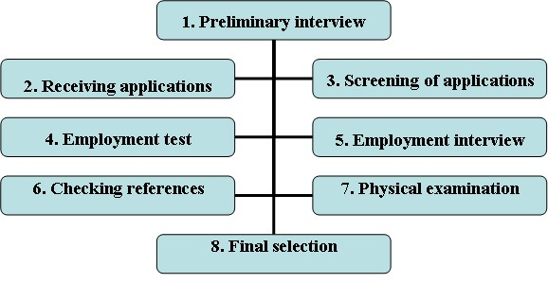
4.Employment test: After getting the interview letter and before going to the interview there is one more step and that is the employment tests. These tests are done to check the ability of the candidate. These tests vary from organization to organization and change as per the need of the particular job. these tests are intelligence tests, aptitude tests, trade tests, interest test, personality tests etc. these tests must be designed properly otherwise they will not good indicator of one knowledge. Some of them are
- Intelligence Tests: These are mental ability tests. They measure the incumbent‟s learning ability and the ability to understand instructions and make judgments. The basic objective of such test is to pick up employees who are alert and quick at learning things so that they can be offered adequate training to improve their skills for the benefit of the organization.
- Aptitude Test: Aptitude test measure an individual‟s potential to learn certain skills- clerical, mechanical, mathematical, etc. These tests indicate whether or not an individual has the capabilities to learn a given job quickly and efficiently. In order to recruit efficient office staff, aptitude tests are necessary
- Personality Test: The definition of personality, methods of measuring personality factors and the relationship between personality factors and actual job criteria has been the subject of much discussion. Researchers have also questioned whether applicants answer all the items truthfully or whether they try to respond in a socially desirable manner. Regardless of these objections, many people still consider personality as an important component of job success.
- Simulation Tests: Simulation exercise is a tests which duplicate many of the activities and problems an employee faces while at work.
- Graphology Test: Graphology involves using a trained evaluator to examine the lines, loops, hooks, stokes, curves and flourishes in a person‟s handwriting to assess the person‟s personality and emotional make-up.6. Polygraph (Lie-Detector) tests: the polygraph records physical changes in the body as the tests subject answers a series of questions. It records fluctuations in respiration, blood pressure and perspiration on a moving roll of graph paper. The polygraph operator forms a judgment as to whether the subject‟s response was truthful or deceptive by examining the biological movements recorded on the paper.

TEST AS SELECTION TOOL:
Tests are useful selection devices in that they uncover qualifications and talents that can‟t be detected otherwise. They can be used to predict how well one would perform if one is hired, why one behaves the way one does, what situational factors influence employee productivity, etc.
Tests also provide unbiased information that can be put to scientific and statistical analysis.

However, tests suffer from sizeable errors of estimate. Most psychological tests also have one common weakness, that is, we can‟t use scales which have a known zero point and equal intervals. An intelligence test, for example starts at an arbitrary point, where a person may not be able to answer question properly. This does not mean that the person is totally lacking in intelligence. Likewise, a person who is able to answer all the10 questions correctly cannot be called twice as intelligent as the one who was able to answer only

5. Employment interview: The candidates who qualify the above tests are called for the employment interview. This interview is done to get more information about the candidate, to give him the actual picture of what is required from him, to check the communication skill of the candidate etc. for senior position post; a panel is prepared who take the interview. At the end of interview of each candidate the members of panel discuss about the candidate and give him the grades.
There may be direct interview or indirect interview. The interview should be conducted in a room free from the noise and disturbance only than the candidates will be able to speak freely and frankly.

Types of interviews:
Several types of interviews are commonly used depending on the nature and importance of the position to be filled within an organization.
In a non directive interview the recruiter asks questions as they come to mind. There is no specific format to be followed.
In a patterned interview, the employer follows a pre-determined sequence of questions. Here the interviewee is given a special form containing questions regarding his technical competence, personality traits, attitudes, motivation, etc.
In a structured or situational interview, there are fixed job related questions that are presented to each applicant. In a panel interview several interviewers question and seek answers from one applicant. The panel members can ask new and incisive questions based on their expertise and experience and elicit deeper and more meaningful expertise from candidates. Interviews can also be designed to create a difficult environment where the applicant‟s confidence level and the ability to stand erect in difficult situations are put to test. These are referred to as the stress interview. This is basically an interview in which the applicant is made uncomfortable by a series of, often, rude, annoying or embarrassing questions.
Steps in interview process:
Interview is an art. It demands a positive frame of mind on part of the interviewers. Interviewers must be treated properly so as to leave a good impression about the company in their minds. HR experts have identified certain steps to be followed while conducting interviews:
PREPARATION:
- Establishing the objective of the interview
- Receiving the candidates application and resume
- Keeping tests score ready, along with interview assessment forms
- Selecting the interview method to be followed
- Choosing the panel of experts who would interview the candidates
- Identifying proper room for environment

- Checking references: Before selecting the employ the prospective employee generally look out for the referees given by the candidate. To check about the candidate‟s past record, reputation, police record etc.
- Physical examination: The organizations generally prefer medical examination to be incurred of the person to avoid time and expenditure spend on the medically unfit person. Sometimes the organization may ask the candidate to get them examined from the medical expert.
- Final selection: After all these steps the candidate is selected finally. He is appointed by issuing appointment letter. Initially he is appointed on probation basis after finding his work satisfactory he is appointed as permanent employee of the organization or otherwise he may be terminated.
Thus, all the above said steps of selection are important for the appointment of right kind of person for the right job.

STRATEGIES FOR SUCESSFUL RECRUITMENT STEP
1: ENSURE AN UP-TO-DATE JOB DESCRIPTION:
A clear, accurate and up-to-date job description is crucial to ensuring a good person-job fit. It is worthwhile spending some time making sure that the job description matches the everyday reality of the job.
2: EVALUATE THE RECRUITMENT STRATEGY:
periodically evaluating the effectiveness of your recruitment strategy, such as the type of sources used for recruiting, can be a useful activity. For instance, a cost-benefit analysis can be done in terms of the number of applicants referred, interviewed, selected, and hired. Comparing the effectiveness of applicants hired from various sources in terms of job performance and absenteeism is also helpful. One could also examine the retention rates of workers who were hired from different sources.

BARRIERS TO EFFECTIVE SELECTION:
The main objective of selection is to hire people having competence and commitment. This objective is often defeated because of certain barriers. The impediments which check effectiveness of selection are perception, fairness, validity, reliability, and pressure.

PERCEPTION: Our inability to understand others accurately is probably the most fundamental barrier to selecting right candidate. Selection demands an individual or a group to assess and compare the respective competencies of others, with the aim of choosing the right persons for the jobs. But our views are highly personalized. We all perceive the world differently. Our limited perceptual ability is obviously a stumbling block to the objective and rational selection of people.

FAIRNESS: Fairness in selection requires that no individual should be discriminated against on the basis of religion, region, race or gender. But the low number of women and other less privileged sections of society in the middle and senior management positions and open discrimination on the basis of age in job advertisements and in the selection process would suggest that all the efforts to minimize inequity have not been very effective.

VALIDITY: Validity, as explained earlier, is a test that helps predict job performance of an incumbent. A test that has been validated can differentiate between the employees who can perform well and those who will not. However, a validated test does not predict job success accurately. It can only increase possibility of success.

RELIABILITY: A reliable method is one which will produce consistent results when repeated in similar situations. Like a validated test, a reliable test may fall to predict job performance with precision.

PRESSURE: Pressure is brought on the selectors by politicians, bureaucrats, relatives, friends, and peers to select particular candidate. Candidates selected because of compulsions are obviously not the right ones. Appointments to public sector undertakings generally take place under such pressure

CHAPTER- 4

REASERCH

AND

METHODOLOGY

RESEARCH METHODOLOGY
The title of present research is "HR Practices in Industrial Sector."

MEANING OF RESEARCH & DEFINITION
Research refers to a search for knowledge. Once can also define research as a scientific and systematic search for pertinent information on a specific topic. Research is an art of scientific investigation. Systematized effort to gain new knowledge.

METHODOLOGY
Methodology can be defined as- ―The analysis of the principles of methods, rules, and postulates employed by a discipline. ―The systematic study of methods that are, can be or have been applied within a discipline. ―A particular procedure or set of procedures .Methodology includes a collection of theories, concepts or ideas as they relate to a particular discipline or field of inquiry: Methodology refers to more than a simple set of methods; ] rather it refers to the rationale and the philosophical assumptions that underlie a particular study relative to the scientific method. This is why scholarly literature often includes a section on the methodology of the researchers. This section does more than outline the researchers‟ methods might explain what the researchers‟ ontological or epistemological views are .Another key (though arguably imprecise) usage for methodology does not refer to research or to the specific analysis techniques. This often refers to anything and everything that can been capsulated for a discipline or a series of processes, activities and tasks.

RESEARCH DESIGN
A research design is simply the framework or plan for a study that is used as a guide in collecting and analyzing the data. It is blueprint that is followed in completing a study. A research design ensures that the study: Will be relevant to the problem
Will employ economical procedure

TYPES OF RESEARCH DESIGN
DESCRIPETIVE RESEARCH
It is typically concerned with determining the frequency with which something occurs or the relationship between two variables. The descriptive study is typically guided by an initial hypothesis. The objective of such a study is to answer the who, when and how of the subject under investigation.

TYPES OF RESEARCH DESIGN USED
The current study is descriptive research with an applied bias. It explains the present industrial scenario and the results of research work may be utilized to enhance efficiency in HR Practices in Industrial Sector.

SOURCES OF DATA COLLECTION
There are two types of sources:
- Primary Sources
- Secondary Sources
I have used both the forms of sources to complete my research.

1. PRIMARY SOURCES
A primary source has been used for obtaining information regarding: facts and quasi-facts, attitudes/options, awareness/knowledge, perception, intentions and behavior, demographic and socioeconomic characteristics.
Primary data is the data collected by
- Interview
- Observation
- Action research
- Case studies
- Life histories
- Questionnaires
2. SECONDARY SOURCES
I used secondary sources like newspaper, journals, and booklets to study the various aspects of an industry
Secondary sources are data that already exists
- Previous research
- Official statistics
- Mass media products
- Diaries
- Letters
- Government reports
- Web information
- Historical data and information

RESEARCH INSTRUMENT
Structured well designed questionnaire is used to gather primary information. In it, questions are presented with exactly the same wording and in exactly the same order, to all respondents.

RESEARCH APPROCH
Survey Research.

CONTACT METHOD
Individual Interviewing.

SAMPALING
It is an integral component of research design. It addresses three questions:
- Whom to survey? (The sample unit)
- How many to survey? (The sample size)
- How to select? (The sampling procedure)
Sampling is necessary because it is almost impossible to examine the entire population. Various factors such as time, efforts, money and purpose of study make it necessary for the researcher to choose a sample.
The sample should be convenient in terms of size i.e. neither too large nor too small and sampling unit must be a true representative of the universe. Besides this, sample should be powerful i.e. the selection process is done keeping in view the objective of the problem.

The total sample size for survey was 50.

LIMITATIONS OF THE STUDY
Every possible effort has been made to make the study complete in all respects but due to a number of uncontrollable factors, the study might have some limitations. These can be as follows:

- The sample size chosen may not be enough to give a true representation of the total population.

- Biasness on the part of respondents while answering the questions cannot be rule out.

- The questionnaire method has the limitation of providing the limited information.

- Effort, time, money factor were another limiting factors during the course of project.

CHAPTER- 5

DATA ANALYSIS

AND

INTERPRETATION

DATA INTERPRETAION:
A questionnaire was prepared for the purpose of getting feedback from the employees and manager regarding „Recruitment & Selection Procedure‟‟ of their company. 30 employees are selected from different department and were distributed the questionnaire from the purpose of the study.
ANALYSIS OF THE DATA:
The analysis of the data is done as per the survey finding. The data is represented in graphically .
The no. of the people opinion were analyzed and expressed in the form of charts and have been placed in the next few pages.

MANPOWER PLANNING:
1. Does your organization plan the recruitment policy?

Strongly Agree | Agree | Disagree | Strongly Disagree
20 | 10 | 0 | 0



written recruitment policy

strongly agree
agree
disagree
srongly disagree
- Interpretation: 20 people are strongly agree with that statement and 10 people are agree with that statement.
2. Do you think the present recruitment policy is helpful in achieving the goal of the company?

Strongly Agree | Agree | Disagree | Strongly Disagree
15 | 10 | 5 | 0

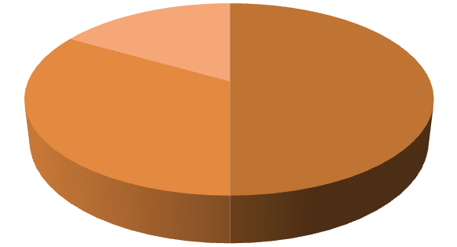

Recruitment policy

strongly agree
agree
disagree
strongly agree

Interpretation :
- 15 people are strongly agree. They said that company‟s policy is helpful in the achieving the goal.
- 10 people are agree.
- 5 people are disagree. They said that company policies is not helpful in the achieving the goal.

- Through which sources organization recruit the employee?

S.No. | Opinion | No. of Respondent
1. | Internally | 6
2. | Externally | 18
3. | Both | 6

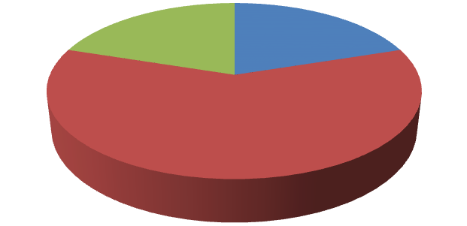

Sources of recruitment

internaly
externaly
both

Interpretation :
6 people said that the company recruit the employee from the internal sources.
18 people said that the company recruit the employee from the external sources.
6 people said that the company recruit the employee from the both sources.

- Which of the following external sources you choose for the recruitment of the employees?

S.No. | Opinion | No. of Respondent
1. | Employee exchange consultant | 6
2. | Private employees Agencies | 6
3. | Advertisement | 3
4. | Internet | 12
5. | Any other | 3

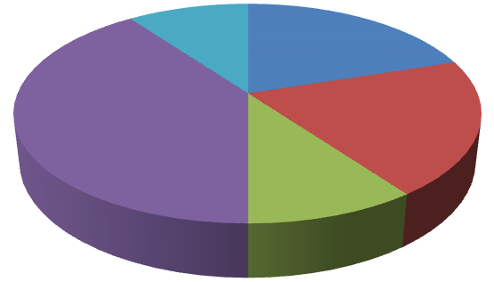

External sources

employee exchange
consultant
private employees
agencies
advertisement
internet

Interpretation:
6 people said that the company uses the employee exchange consultants.
6 people said that the company uses private employment agencies.
3 people said that the company uses the advertisement method.
12 people said that the company uses the internet method.
3 people said that the company uses the any other way.

- Is company use own web site for recruitment ?

S.No. | Opinion | No. of respondent
1. | Yes | 27
2. | No | 3

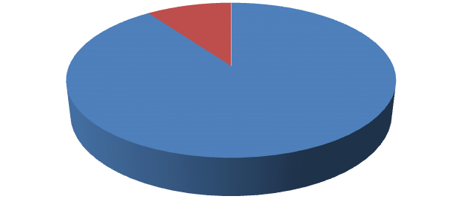

Use own web site

Yes
No

Interpretation :
27 people said that the company uses its own web site for recruitment.
3 people said that the company not uses his own web site.

- Does the procedure adopted for recruitment and selection of employees enables to give right person at the right job ?

S.No. | Opinion | No. of respondent
1. | Yes | 21
2. | No | 3
3. | To some extent | 6

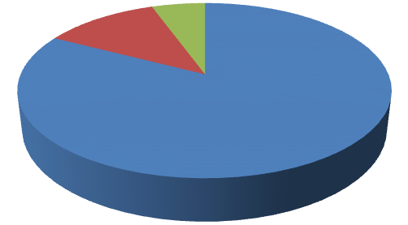

Placement of right person to
the right job

Yes
No
To some extent

Interpretation :
21 people said that the procedure adopted for recruitment and selection of employees enable to place the right person for the right job.
  - people said that the procedure adopted for recruitment and selection of employees does not enable to place the right person for the right job.
6 people said that the procedure adopted for recruitment and selection of employees enable to some extent place the right person for the right job.

- Which type of technique is used for interview ?
S. No. | Opinion | No. of respondent
1. | Structured | 18
2. | Unstructured | 3
3. | Both | 9

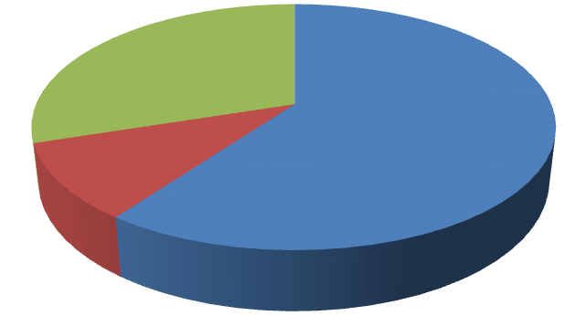

Techniques for selection

structured
unstructured
Both

Interpretation:
18 people said that the company uses the structured techniques for selection.
  - people said that the company uses the unstructured techniques for selection.
9 people said that the company uses the both the techniques for selection.

- Is there any provision for evaluation and control of recruitment and selection process?

S. No. | Opinion | No. of respondent
1. | Yes | 24
2. | No | 6



Evaluation & control of
recruitment and selection
process

Yes
No

Interpretation:
24 people said that the company has the provision for evaluation and control of recruitment and selection.
6 people said that the company does not have the provision for evaluation and control of recruitment and selection.

CHAPTER- 6

FINDING

CONCLUSION

&

RECOMMENDATION

SUMMARY:
In this study there were 30 employees of Pico Marketing Ltd who responded to the questionnaire. The answers provided by them were a positive response on the mode of recruitment. They were satisfied with the whole step by step process. There was very little negative response and were very few no opinions given by the respondents over the whole process. So as a fresher they were satisfied with the process and appreciate the transparency followed by Pico Marketing Ltd in the recruitment process. It is clear from the above that Pico Marketing Ltd is adopting transparency and well communicates recruitment process.

FINDINGS:
Toyoda have a lot of strengths in recruiting and selection procedure. Findings derived from question-answer sample personnel as primary source and company‟s book and records as secondary source. Answer to some important questions on the subject matters has been presented below:
- The lack of human resource Department but they have human resources planning. Although after a certain time activities are not monitor properly.
- They have gone through the policy of recruitment and selection but no HR budget on HR or HR planning.
- Their Job analysis process is not fair. Increment and incentive is depending on their mental satisfaction. Their HR planning but any kind of dispute all staffs are responsible for that. The luck of proper work distribution is the main reason behind that.
- Requisition for employment is not measure accurately. So many qualified people are recruited but they have a habit of negligence of responsibilities.
- They have informal selection process which is satisfied, but all existing staffs need to co-ordinate properly by the right hand.
- The exiting procedures are very much time consuming.
- They do not allow any women as Board Member.
- They do not keep of finally rejected a resume which is very much important
- Their recruitment and selection transparent.

- No medical test, no orientation before final placement.

There have been no such weaknesses in recruiting and selection procedures which mean that they are selecting right people for their organization. Always remember, educated and experienced person can give extra ordinary performance all the time. But their evaluation, time to time correlation and co-operation for betterment are necessary. By a proper process we can get better but after selection it‟s also mandatory to fulfill every expectation of the employees.

LIMITATION:
As the research is based on a sample, therefore findings may not reveal the factual information about the research problem, though an utmost care was taken to select the truly representative sample. Carrying this survey was a great learning experience for me but I faced some problems, which are listed below:
- There is small sample size of the study due to organizational constraints.
- Many of the respondents have not given proper response that makes the data collection vague to certain extent.
- The information that is provided by the individual may be biased.
- Time constraint is the major constraint of the study.
- Only a small part of industry and small sample size is taken only from the employees working at neemrana branch.
- Generally the respondents were busy in their work and were not interested in responding rightly.

CONCLUSION:
Materials, People, systems, tools, knowledge, management, equipment, processes, skill and attitudes all are input for any king of production cycle in an organization. To increase productivity of any organization they need to develop staffing process properly and consider the following important ISSUES:
Planning Motivation Organizing Managerial Function s Staffing Directing Co-Coordinating Controlling
Transformation of the demographic makes up of the workforce, including internationalization, Quality of employee recruitment decision must be ensured, Recruitment and selection processes are complex and involve human making so that, there should careful monitoring to minimize subjectivity and ensure fairness, Human is the most dynamic resources for an organization, getting the best person is a critical task, Recruitment and selection are an integral component of human resources activities, which include employees training, development, compensation and employee relation. To increase productivity, growth and progress, effective and dynamic recruitment and selection procedures are essential. A qualified person is the beginning of better performance. All organization needs a strong team to accomplish their goals and objectives.
Without proper recruitment and selection process, it‟s too tough to build up dynamic working group and successive atmosphere for all tasks.

RECCOMANDATION:
To improve the present „Recruitment and Selection Policy” of Toyoda gosai Minda pvt. Ltd the following recommendations have been suggested:
- An ideal and independent HR Department should be functioned
- Every recruitment and selection process should be according to job analysis.
- Lengthy and time consuming should be Revised into their policy
- As an interviewer at least one women is to be added in the interview panel
- Manpower planning is to be established
- Recruitment policy should be checked from time to time by experts so that necessary change can be made in the policy
- Recruitment is to be done exclusively under HRD or a single department.
- They should avoid relative biasness in terms of recruitment.
- Always quality should be kept up and to be set up with the objective of recruitment and selection procedures to the company objectives.
- Preparation and maintenance of service rule is needed.
s

SUGGESTIONS:
- Entrepreneurs should go for campus placement on large scale as source of external recruitment so that capable students make contribution in growth of Industry.
- During training procedure, entrepreneurs should give preference to job rotation because in job rotation, employees feels some changes regarding place, environment etc. and take more interest in their work.
- To make easy and congenial environment in organization, it is necessary that entrepreneurs should interact with their supervisors on regular basis.

BIBLOGRAPHY:
A bibliography is an alphabetized list of sources that have been used to compile data, typically in an article, essay, or research paper.

WEBSITES:
- www.hr.com
- www.hrindia.com
- www.humancapitalonline.com
- www. Wikipedia.com
- www.slideshare.com • www.google.com

BOOK REFERANCES:
- Human Resource Management – Niilm University , Kaithal, (Haryana)
- Human Resource and Personnel Management, McGraw Hill ➢ Werther, W.B and Davis, K.
- Human Resource Management , k. Aswathapha

OTHERS SOURCES:
- Dictionary
- An article
- journal or magazine
- Abbreviation
- &

ANNEXURE

QUESTIONNAIRE
Survey on the managerial satisfaction level for recruitment and selection
DEAR respondent,
We are conducting a survey on the managerial satisfaction level for the RECURITMENT SELECTION PROCEDURE. Your free and frank opinion would be very valuable in conducting the survey. Please answer the following questions with a (.) in the appropriate boxes.

RECRUITMENT POLICY:
- Does your organization plan the recruitment policy ?
a). strongly agree b). agree
c). disagree d). strongly disagree

- Do you think the present recruitment policy is helpful in achieving the goal of the company?
a). Strongly agree b). agree
c). Disagree c). Strongly disagree

SOURCES OF RECRUITMENT:
- Through which sources your organization recruit the employees?
a).Internally b). Externally
c). Both

- Which of the following external sources you choose for the recruitment of the employees?
a). Employee exchange consultants
b). Private employee agencies
c). Campus recruitments
d).Advertisements
e). Any other…………

LATEST TECHNIQUES OF RECRUITMENT:

- If yes then the company use own website or this purpose?
a). Yes b). No
- Is internet recruitment is effective in your opinion?
a). Yes b). No
SELECTION POLICY:

- Which type of technique is used for interview?
a). Structured b). Unstructured
c). Both

FEEDBACK OFRECRUITMENT AND SELECTION PROCEDURE:

- Is there any provision for evaluation of recruitment and selection process?
a). Yes b). No

- Does the procedure adopted for recruitment and selection of employees enables to give right person at the right job?
a).Yes b). No

