**BASIC FINANCIAL MANAGEMENT-I**

**Semester: 5th Semester IMBA**

**Subject Code: 161MN501**

**Prepared By**

**Name of the Faculty: SHAHNI SINGH**

**Designation: ASSISTANT PROFESSOR**

**Department: FINANCE**

**Biju Patnaik Institute of IT & Management Studies,**

**Bhubaneswar, Odisha.**

**Syllabus**

**Module-I**

Introduction: Introduction to Financial Management, Financial Process, Scope of Financial Management, Goals of the firm (Profit Maximum Vs Wealth Maximum), Objectives of Financial Management in contemporary business environment.

**Module-II**

Long-term Financing Decisions: Financial Markets, Money Markets, Capital Markets (Capital market Institutions), Types of Issue, Types of share capital, Debentures, Relative merits and demerits; Stock Indices (Sensex, Nifty).

Investment decisions: Time value of money, Future value and compounding, Present value and discounting; Concept of Return and Risk, CAPM Model, Concept of value; Nature and Types of investment decision, Investment evaluation criteria (NPV, IRR, Payback, Discounted payback)

**Module-III**

Cost of Capital: Significance of Cost of Capital; Determining components of cost of capital – Cost of Debt, Preference Share Capital, Equity share capital, Cost of Retained earning, WACC.

**Module-IV**

Capital Structure: Concept of Leverage, Types of Leverage, Capitalization, Theories of capitalization, Over and under capitalization, watered stock/capital, Capital Structure Theories – Relevance and irrelevance theories.

**Content Table**

|  |  |  |  |
| --- | --- | --- | --- |
| **Sl. No.** | **Details of Content** | **Page No.** | **Remarks** |
| 1 | Profit maximization vs wealth maximization | 13 | Distinction |
| 2 | Money market and capital market | 16 | Distinction |
| 3 | Primary market and secondary market | 20 | Distinction |
| 4. | Share and debenture | 24 | Difference |
| 5. | Share and preference share | 25 | Difference |
| 6 | Syatematic and unsystematic risk | 41 | Difference |
| 7. | Operating leverage and financial leverage | 79 | Difference |

**List of Figures**

|  |  |  |  |
| --- | --- | --- | --- |
| **Sl. No.** | **Detail of Figure** | **Page No.** | **Remarks** |
| 1 | Risk return |  | Graph |
| 2 | Risk return |  | Graph |
| 3 | CAPM |  | Graph |
| 4 | NI |  | Graph |
| 5 | NOI |  | Graph |
| 6 | Traditional approach |  | Graph |

**Course Objectives (CO) & Program Outcomes (PO)**

**Course Objectives (CO):**

**Course Objectives:**

1. To help the students to develop cognizance of the importance of Financial Management in corporate valuation.
2. To provide the students to analyze specific characteristics of long term financing.
3. To enable students to describe how people analyze the corporate leverage under different conditions and understand why people valuate different corporates in different manner

**Program Outcomes (PO):**

* Demonstrate the applicability of the concept of Financial Management to understand the managerial Decisions and Corporate Capital Structure.
* Apply the CAPM model, NPV and IRR Analysis associate with Financial Data in the corporate.
* Demonstrate how the concepts of financial management and investment, financing and dividend policy decisions could integrate while identification and resolution of problems.

**Introduction**

**(Details overviews of subjects including all modules)**

Financial Management means planning, organizing, directing and controlling the financial activities such as procurement and utilization of funds of the enterprise. It means applying general management principles to financial resources of the enterprise. Financial management refers to the functions involved in the management of financial resources. These functions are fund procurement, working capital management, capital budgeting, and capital structure designing of an organization.It includes controlling and maintaining the financial assets of an organization. In addition, it determines the future strategies related to expansion, diversification, joint venture, and mergers and acquisitions.The investment decision process: • Generate cash flow forecasts for the projects, • Determine the appropriate opportunity cost of capital, • Use the cash flows and the cost of capital to compute the relevant investment criteria. Financing decisions are the financial decisions related to raising of finance. It involves identification of various sources of finance and the quantum of finance to be raised from long-term and short-term sources. A firm can raise long term finance either through shareholders' funds or borrowed capital. Cost of capital is a company's calculation of the minimum return that would be necessary in order to justify undertaking a [capital budgeting](https://www.investopedia.com/terms/c/capitalbudgeting.asp) project, such as building a new factory.

The term cost of capital is used by analysts and investors, but it is always an evaluation of whether a projected decision can be justified by its cost. Investors may also use the term to refer to an evaluation of an investment's potential return in relation to its cost and its risks.

Many companies use a combination of debt and equity to finance business expansion. For such companies, the overall cost of capital is derived from the weighted average cost of all capital sources. This is known as the [weighted average cost of capital](https://www.investopedia.com/terms/w/wacc.asp) (WACC).

Capital structure refers to the specific mix of debt and equity used to finance a company's assets and operations. The capital structure theories explore the relationship between your company's use of debt and equity financing and the value of the firm. The capital structure theories use the following assumptions for simplicity:

1. The firm uses only two sources of funds: debt and equity.
2. The effects of taxes are ignored.
3. There is no change in investment decisions or in the firm's total assets.
4. No income is retained.
5. Business risk is unaffected by the financing mix.

**Financial Management**

Financial process management is a way to get separate finance-related business functions to run in a smooth, coordinated way. It is the technique by which you streamline the various financial business processes in your organization, and get them to function as a single coherent, consistent unit. Financial management is managerial activity which is concerned with the planning and controlling of the firm’s financial resources. J.E. Brandley defines financial management as that area of business management devoted to judicious use of capital and a careful selection of the source of capital in order to enable a spending unit to move in the direction of reaching the goals.

Howard and Uptron define Financial Management “as an application of general managerial principles to the area of financial decision- making.”

Weston and Brighem define Financial Management “as an area of financial decision making, harmonizing individual motives and enterprise goal.”

Financial management:-

* Efficient acquisition of finance (owned funds or borrowed funds)
* Efficient utilization of finance
* Efficient distribution of surplus (how to distribute and how much to distribute)

For smooth functioning of business.

**Scope of financial management**

1. Estimating financial requirements- the first task of a financial manager is to estimate short term and long term financial requirements of his business. For this purpose, he will prepare a financial plan for present as well as future. The amount required for purchasing fixed assets as well as needs of funds for working capital will have to be ascertained. The estimations should be based on sound financial principles so that neither there are inadequate nor excess funds with the concern. The inadequacy of funds will adversely affect the day to day working of the concern whereas excess funds may tempt a management to indulge in extravagant spending or speculative.
2. Deciding capital structure- the capital structure refers to the kind of proportion of different securities for raising funds. After deciding about the quantum of funds required it should be decided which type of securities should be raised. It may be wise to finance fixed assets through long term debts. Even here if gestation period is longer, then share capital may be most suitable. Long term funds should be employed to finance working capital also, if not wholly then partially. Entirely depending upon overdrafts and cash credits for meeting working capital needs may not be suitable. A decision about various sources for funds should be linked to the cost of raising funds. If cost of raising funds is very high then such sources may not be useful for long. A decision about the kind of securities to be employed and the proportion in which these should be used is an important decision which influences the short term and long term financial planning of an enterprise.
3. Selecting a source of finance- after preparing a capital structure, an appropriate source of finance is selected. Various sources from which finance may be raised, include share capital, debentures, financial institutions, commercial banks, public deposits. If finances are needed for short periods then banks, public deposits and financial institutions may be appropriate; on the other hand, if long term finances are required then share capital and debentures may be useful. If the concern does not want to tie down assets as securities then public deposits may be a suitable source. If management does not want to dilute ownership then debentures should be issued in preference to shares. The need, purpose, object and cost involved may be the factors influencing the selection of a suitable source of financing.
4. Proper use of surplus- the utilization of profits or surpluses is also an important factor in financial management. A judicious use of surpluses is essential for expansion and diversification plans and also in protecting the interests of shareholders. The ploughing back of profits is the best policy of further financing but it clashes with the interests of shareholders. A balance should be struck in using funds for paying dividend by the declaration of dividend and expected profitability in future. A finance manager should consider the influence of various factors such as trend of earnings of an enterprise, expected earnings in future, market value of shares, need for funds for financing expansion. A judicious policy for distributing surpluses will be essential for maintaining proper growth of the unit.
5. Proper cash management- cash management is also an important task of finance manager. He has to assess various cash needs at different times and then make arrangements for arranging cash. Cash may be required to purchase raw materials, make payments to creditors, meet wage bills, meet day to day expenses. The usual sources of cash may be cash sales, collection of debts, short term arrangements with banks. The cash management should be such that neither there is a shortage of it and nor it is idle. Any shortage of cash will damage the creditworthiness of the enterprise. The idle cash with the business will mean that it is not properly used. It will be better if cash flow statement is regularly prepared so that one is able to find out various sources and applications. If cash is spent on avoidable expenses then such spending may be curtailed. A proper idea on sources of cash inflow may also enable to assess the utility of various sources. Some sources may not be providing that much cash which we should have thought. All this information will help in efficient management of cash.
6. Portfolio management- it is concerned with the efficient management of investment in securities. Here, an investment can be defined as the current commitment of funds for a period of time in order to derive a flow of funds in future which would compensate the investor. It involves a complex process of selection of securities taking into account different types of risks involved in such investment as well as the return from such investment. The investor’s attitude towards risks influences the pattern of investment. At present, portfolio management is supposed to be the most important area of financial management.
7. Management of retained earnings- in any business firm a portion of its profits has to be distributed as dividends to its shareholders and the remaining portion is retained for reinvestment purposes. This retained earnings constitute the internal source of funds for any firm. The payment of dividends causes a depletion of total assets of the firm. If the firm fails to raise its required funds from outside sources its future growth would be affected. Hence, the management should also design proper retention policy or a dividend policy that would fulfill the expectations of the shareholders without affecting the future growth of the firm. Thus, the dividend policy/ retention policy of a business enterprise also comes under the purview of financial management.

**Functions of financial management**

1. Investment decision- The investment decision is concerned with the selection of assets in which funds will be invested by a firm. The asset of a business firms includes long term assets (fixed assets) and short term assets (current assets). Long term assets will yield a return over a period of time in future whereas short term assets are those assets which are easily convertible into cash within an accounting period. The long term investment decision.is known as capital budgeting whereas short term investment decision is identified as working capital management.

* Relates to selection of asset in which fund will be invested by firm.
* Every firm wants to invest in most appropriate option which brings maximum return.
* Firm can invest its funds in acquiring fixed assets as well as current asset.

1. Dividend decision- Dividend of a firm to the policy decisions are concerned with the distribution of profits of a firm to the shareholders. How much of the profits should be paid as dividend? i.e dividend payout ratio. The decision will depend upon the preferences of the shareholder, investment opportunities available within the firm and the opportunities for future expansion of the firm. The dividend payout ratio is to be determined in the light of the objectives of maximizing the market value of the share. The dividend decisions must be analysed in relation to the financing decisions of the firm to determine the portion of retained earnings as a means of direct financing for the future expansions of the firm.
2. Financing decision- the financing decision is concerned with capital mix or capital structure of a firm. The term capital structure refers to the proportion of debentures capital and equity share capital. Financing decision of a firm relates to the financing mix. This must be decided taking into account the cost of capital, risk and return to the shareholders. Employment of debt capital implies a higher return to the shareholders and also the financial risk. There is a conflict between return and risk in the financing decisions of a firm. So, the finance manager has to bring a tradeoff between risk and return by maintaining a proper balance between debt capital and equity share capital. On the other hand, it is also the responsibility of the finance manager to determine an appropriate capital structure.

**Objectives of financial management**

1. Profit maximization: This is the main objective of financial management. The finance manager strives to achieve optimal profit in the short term and long-term course of business. The finance manager shall try to achieve as high as profits. The company makes a decent profit in the long run if the finance manager makes the proper decisions using the various methods and tools available
2. Wealth maximization:  It means shareholders’ value maximization. Wealth maximization means earning maximum wealth for shareholders. So, the finance manager tries to give maximum dividends to shareholders. The dividend declaration and payout policy are decided by financial management. Dividend decisions include a proper dividend policy regarding the distribution or retaining of company profits. This is related to the performance of the company. Better the performance, the higher is the market value of shares. In nutshell, the finance manager tries to maximize shareholders’ value.
3. Proper mobilization: Mobilization of finance is an important objective of financial management. It means utilizing effectively the sources of finance. The finance manager can manage various sources of funds such as shares, debentures, after estimating the financial requirements, the finance manager must decide about the sources of finance.
4. Increase efficiency: Financial management tries to increase the efficiency of all sections of the company. Proper distribution of finance to all departments increases the efficiency of the entire company.
5. Proper estimation of total financial requirements: This means that the finance manager would be able to estimate the financial requirements of the company. He should be able to compute how much financing is required to start and run the business/ He shall estimate the fixed and working capital requirements of the company. If not, there will be a shortage or surplus of finance. The finance manager shall use various factors like the technology used by the company, the number of employees used, the scale of operations, and legal requirements.
6. Proper utilization of finance: The finance manager must make optimum utilization of finance. This can be done by using various financial tools as managing receivables, effective payment policy in hand, and better inventory management.
7. Maintaining proper cash flow: The financial manager shall ensure that there is a regular supply of liquidity in the company monitoring closely all the cash inflows and outflows reducing the instances of underflow and overflow of cash. The finance manager is entrusted with the responsibility to maintain an optimum level of liquidity. Healthy cash flow improves the chances of survival and success of the company.
8. Survival of company: The company must survive in this competitive business world. Hence, the finance manager shall take all the decisions intuitively. The big decisions shall be taken with proper due diligence and consultancy with consultants.
9. Creating reserves: The higher the reserves, the better it will be for the company to overcome uncertainty. The company shall have an optimal dividend payout policy that will help itself to create reserves over the year. It must also keep the profits as reserves. The reserves can be used for the expansion of the company and overcoming uncertainty. It can also be used to face contingencies in the future.
10. Reduce the cost of capital: This includes risk evaluation, measuring the cost of capital, and estimating benefits out of a particular project. Managers are responsible for deciding how available funds should be invested in fixed or current assets to get the best available returns.
11. Reduce operating risks: The company goes through various risks and uncertainties. The finance manager must take steps to reduce these risks. This can be done by avoiding high-risk allocation of capital for expansion All the decisions shall be taken with proper consultancy.
12. Prepare capital structure: This means bringing a proper balance between the different sources of capital. This balance is necessary for liquidity, economy, flexibility, and stability.

**Profit maximization vs wealth maximization**

For optimal financial decisions, it is essential to define objectives of financial management. These objectives serve as decision criterion. Financing is a functional area business and therefore, the objectives of financial management must be in tune with the overall objectives of the business. The main objectives of business are survival and growth. In order to survive in the business and to grow, a business must earn sufficient profits. It must also maintain good realtions with investors, employees, customers and other groups of society. It should also provide maximization of owner’s economic welfare. Consequently, there are two well-known criteria in this regard:

Profit maximization- according to this criterion, the financial decisions (investment, financing and dividend) of a firm should be oriented to the maximization of profits ( i.e select those assets, projects and decisions which are profitable and reject those which are not profitable). Hence, actions that increase the firm’s profit are undertaken while those that decrease profit are avoided.

Merits:-

* Allocation of resources
* Main source of inspiration
* Maximum social welfare
* Basis of decision making

Under perfect competition, profit maximization behavior by firms leads to an efficient allocation of resources with maximum social welfare. Since, the capital is a scarce material, the financial manager should use these capital funds in the most efficient manner for achieving the profit maximization. It is therefore, argued that profitability maximization should serve as the basic criterion for the ultimate financial management decisions.

Drawbacks:-

* It is vague
* It ignores time value of money
* It ignores risks
* It ignores social responsibility

Wealth maximization- considering the shortcomings of profit maximization, wealth maximization is taken as the basic objective of financial management. It is also known as ‘value maximization’ or ‘net present value maximization’. The wealth maximization goal states that the management should seek to maximize the present value of the expected returns of the firm. The present value of future benefits is calculated by using its discount rate (cost of capital) that reflects both time and risk.

Features/objectives:-

1. It measures income in terms of cash flows, and avoids the ambiguity now associated with accounting profits as, income from investments is measured on the basis of cash flows rather than on accounting profits.
2. It recognizes time value of money by discounting the expected income of different years at a certain discount rate (cost of capital).
3. It analyses risk and uncertainty so that the best course of action can be selected from different alternatives.
4. It is not in conflict with other motives like maximisation of sales or market value of shares. It helps rather in the achievement of all these other objectives.

|  |  |
| --- | --- |
| **Profit maximization** | **Wealth maximization** |
| It is a traditional approach | It is a modern approach |
| It emphasizes short term | It emphasizes long term |
| It ignores time value of money | It considers time value of money |
| It ignores risk and uncertainty | It recognizes risk and uncertainty |
| It measures the performance of a business firm only on the basis of its profit | It measures the performance of a business firm only on the basis of shareholders wealth |
| It is based on the assumption of perfect competition in the product market | It assumes an efficient capital market |
| A firm may not pay regular dividends to its shareholders and reinvest its retained earnings to achieve this goal | A firm pays regular dividends to its shareholders to achieve this goal |

**Functions of finance manager**

1. Estimating the Amount of Capital Required: This is the foremost function of the financial manager. Business firms require capital for:

(i) purchase of fixed assets,

(ii) meeting working capital requirements, and

(iii) modernisation and expansion of business.

The financial manager makes estimates of funds required for both short-term and long-term.

#### 2. Determining Capital Structure: Once the requirement of capital funds has been determined, a decision regarding the kind and proportion of various sources of funds has to be taken. For this, financial manager has to determine the proper mix of equity and debt and short-term and long-term debt ratio. This is done to achieve minimum cost of capital and maximise shareholders wealth.

#### 3. Choice of Sources of Funds: Before the actual procurement of funds, the finance manager has to decide the sources from which the funds are to be raised. The management can raise finance from various sources like equity shareholders, preference shareholders, debenture- holders, banks and other financial institutions, public deposits, etc.

#### 4. Procurement of Funds: The financial manager takes steps to procure the funds required for the business. It might require negotiation with creditors and financial institutions, issue of prospectus, etc. The procurement of funds is dependent not only upon cost of raising funds but also on other factors like general market conditions, choice of investors, government policy, etc.

#### 5. Utilization of Funds: The funds procured by the financial manager are to be prudently invested in various assets so as to maximize the return on investment: While taking investment decisions, management should be guided by three important principles, viz., safety, profitability, and liquidity.

#### 6. Disposal of Profits or Surplus: The financial manager has to decide how much to retain for ploughing back and how much to distribute as dividend to shareholders out of the profits of the company. The factors which influence these decisions include the trend of earnings of the company, the trend of the market price of its shares, the requirements of funds for self- financing the future programmes and so on.

#### 7. Management of Cash: Management of cash and other current assets is an important task of financial manager. It involves forecasting the cash inflows and outflows to ensure that there is neither shortage nor surplus of cash with the firm. Sufficient funds must be available for purchase of materials, payment of wages and meeting day-to-day expenses.

#### 8. Financial Control: Evaluation of financial performance is also an important function of financial manager. The overall measure of evaluation is Return on Investment (ROI). The other techniques of financial control and evaluation include budgetary control, cost control, internal audit, break-even analysis and ratio analysis. The financial manager must lay emphasis on financial planning as well.

**MODULE II**

**Difference between capital market and money market**

|  |  |  |
| --- | --- | --- |
| Basis | Money Market | Capital Market |
| Definition | Money market is the market from where short term capital is collected for industry, trade and business. | Capital market is the market from where long term capital is collected for the purpose of industry, trade and business. |
| Types of capital | Money market supplies short-term capital. | Capital market supplies long-term capital. |
| Segments | The important segments of money market are- treasury bill market, commercial paper, call money market, certificates of deposit markets. | Capital market may be divided into two segments called Primary Market and Secondary Market. |
| Protection of interests | Makes arrangement for investment to protect their own interest with depositors’ money. | Makes arrangement for investment to protect the investors’ interest. |
| Regulation | The Reserve Bank Of India (RBI) is regulated by Indian money market | Capital market in India is regulated by Securities Exchange Board of India (SEBI). |
| Use of capital | Capital collected from money market is used to meet current capital only | Capital collected from capital market is used to purchase fixed asset and meet deficiency of current capital. |

**Features of Indian Capital Market**

Nature and structure of capital market depend on economic condition of the country. As capital markets of England and USA have their own features, Indian capital market has some features too the features are discussed below:-

1. Capital formation- One of the main features of capital market is a capital formation. Capital market offers attractive opportunities to those who have surplus funds so that they invest more and more in capital market and are encouraged to save more for profitable opportunities. Small savings of people are deposited in capital market as investment and form a monetary market. Long term loan is provided to different business institutions from this monetary fund. Capital market functions as link between saver and borrower.
2. Transaction of new and existing securities- Capital market is a market where existing and new securities are traded.
3. Lack of efficient agencies- Industrial bank, underwriting agencies, share issue house- all these expert institutions are found in capital market of foreign countries. But such expert organisations are lacking in capital market of India.
4. Government efforts- Investment trust and insurance companies which play important role in other countries do not play the same role in India. So, to stabilise capital market in India, UTI and LIC have been set up by government initiative.
5. Arrangement of long term loan- Different investment institutions make arrangement of long term loan for industry and commerce in the capital market in India.

**Functions of Indian Capital Market**

Capital market plays an important role in the development of industry, trade and commerce of any country. Capital market plays an important role in mobilising resources, and diverting them in productive channels. In this way, it facilitates and promotes the process of economic growth in the country. Functions of Indian capital market are discussed below:

1. Help to establish and expansion of industry and commerce- Fixed capital is required for establishment, expansion and continuity of industrial and commercial institutions, capital market supplies necessary money for these requirements. But nature of the constituents of capital market being different, their functions are also of different types. For example, stock exchange of capital market does not supply capital directly, it creates scope for capital investment in trade and commerce by creating scope for transaction of share, debenture and government securities.
2. **Link between Savers and Investors-** The capital market functions as a link between savers and investors. It plays an important role in mobilising the savings and diverting them in productive investment. In this way, capital market plays a vital role in transferring the financial resources from surplus and wasteful areas to deficit and productive areas, thus increasing the productivity and prosperity of the country.
3. **Encouragement to Savings-** With the development of capital, market, the banking and non-banking institutions provide facilities, which encourage people to save more. In the less- developed countries, in the absence of a capital market, there are very little savings and those who save often invest their savings in unproductive and wasteful directions, i.e., in real estate (like land, gold, and jewellery) and conspicuous consumption.
4. **Promotes Economic Growth-** The capital market not only reflects the general condition of the economy, but also smoothens and accelerates the process of economic growth. Various institutions of the capital market, like nonbank financial intermediaries, allocate the resources rationally in accordance with the development needs of the country. The proper allocation of resources results in the expansion of trade and industry in both public and private sectors, thus promoting balanced economic growth in the country.
5. High standard of living- Capital market supplies long term loan or capital to the industries, trade and commerce. With the help of this loan industry purchased machinery and technical know-how. Therefore goods are purchased at cheap cost and consumers are also getting low price. In consequence standard of living will be increased.

**Importance of Capital Market**

Capital market plays an important role in the development of industry, and commerce of any country. According to S.C.Kuchal, “It consists of a series of channels through which the savings of the community are made available for industrial and commercial enterprises and public authorities.” So importance of capital market is immense in economic development. Such as:-

1. Help to establishment and expansion of industry and commerce- Fixed capital is required for establishment, expansion and continuity of industrial and commercial institutions, capital market supplies necessary money for these requirements. But nature of the constituents of capital market being different, their different, their functions are also of different types. For example, stock exchange of capital market does not supply capital directly, it creates scope for capital investment in trade and commerce by creating scope for transaction of share, debenture and government securities. So contribution of capital market is undeniable for industrial development and progress of trade and commerce in the country.
2. Mobilization of savings and acceleration of capital formation- In developing countries like India the importance of capital market is self evident. In this market, various types of securities helps to mobilize savings from various sectors of population. The twin features of reasonable return and liquidity in stock exchange are definite incentives to the people to invest in securities. This accelerates the capital formation in the country.
3. Promotion of industrial growth- The stock exchange is a central market through which resources are transferred to the industrial sector of the economy. The existence of such an institution encourages people to invest in productive channels. Thus it stimulates industrial growth and economic development of the country by mobilizing funds for investment in the corporate securities.
4. Ready and continuous market- The stock exchange provides a central convenient place where buyers and sellers can easily purchase and sell securities. Easy marketability makes investment in securities more liquid as compared to other assets.
5. Technical assistance- An important shortage faced by entrepreneurs in developing countries is technical assistance. By offering advisory services relating to preparation of feasibility reports, identifying growth potential and training entrepreneurs in project management, the financial intermediaries in capital market play an important role.

**Types of capital market**

The Capital market can be divided into two parts:-

1. Primary Market
2. Secondary Market
3. Primary Market- The primary market is also known as the new issues market. It deals with new securities being issued for the first time. The functions of Primary market is to facilitate the transfer of investible funds savers to entrepreneurs seeking to establish new enterprise or to expand existing ones through the issue of securities for the first time. The investors in this market are banks, financial institutions, insurance companies, mutual funds and individuals. Methods of floatation new issue in the primary market are offer through Prospectus, Offer for Sale, Private Placement, Right issue etc.
4. Secondary Market- The secondary market is also known as the stock market or stock exchange. It is a market for the purchase and sale of existing securities. It helps existing investors to disinvest and fresh investors to enter the market. It also provides liquidity and marketability to existing securities.

**Difference between primary market and secondary market.**

|  |  |  |
| --- | --- | --- |
| Basis | Primary Market | Secondary Market |
| Meaning | The market place for new shares is called primary market. | The place where formerly issued securities are traded is known as Secondary Market. |
| Purchasing | There is a direct purchase between the issuers and investors. | There is a indirect purchase between the issuers and investors. |
| Selling | The securities are traded or sold only once in primary market. | The securities are traded or sold multiple times. |
| Intermediary | The underwriters acts as an intermediary. | The brokers act as an intermediary in the secondary/ stock market. |
| Structure. | Does not have any physical structure or geographical location. | It is tangible and has a physical existence. |

**Equity Shares**

The equity shares may be regarded as the foundation of the financial structure of a company. They occupy a primary position. They represent the ownership capital of a company. The equity shareholders collectively own the company and enjoy all rewards and risks associated with such ownership. They do not have any preferential rights regarding either the payment of dividend or the repayment of capital at the time of company’s liquidation.

**Preference Shares**

Preference share represents a particular portion of the share capital which has been endowed with certain preferences and limitations. It represents a hybrid security that have some characteristics of equity shares and some attributes of debentures.

Types:-

1. Cumulative and non-cumulative preference shares- In case of cumulative preference shares dividends not paid in a particular year are carried forward to the next year. Such unpaid dividends go on accumulating and become payable out of the profits in subsequent years. Such arrears of dividend must be paid before dividend is paid on any other class of shares. Unless otherwise stated preference shares are cumulative. On non-cumulative preference shares dividends do not accumulate. In case the company does not declare dividend in any year, the right to dividend in any year, the right to dividend in respect of that year is lost forever. The dividend claim is not carried to subsequent year.
2. Participating and non-participating preference shares- Participating preference shares give the holder the right to share in the profits left after the payment of dividend to preference and equity shareholders. On the contrary, the holders of non-participating preference shares do not enjoy the right share in the surplus profits. They get only the fixed dividend.
3. Convertible and non-convertible preference shares- Holders of a convertible preference shares can get such shares converted into equity shares after a fixed period. On the other hand, shares which cannot be converted into equity shares are known as non-convertible preference shares.
4. Redeemable and irredeemable preference shares- The holders of redeemable preference shares can be refunded their capital after the expiry of a specified period or at the discretion of the company. Only a company limited by shares can issue redeemable preference shares. The intention to return money should be made clear when the shares are issued. The Companies act lays down several conditions for the redemption of preference shares. Non-redeemable preference shares cannot be redeemed before the winding up of the company. However, the Companies Amendment Act 1996 lays down that preference shares cannot be issued for a period of more than twenty years.

**Debentures**

Debentures are another kind of security traded in the capital market. A debenture is an acknowledgement of a debt by a company, usually issued under a common seal, and unsecured or secured by a fixed or floating charge on the assets of the company. The terms and conditions under which they are issued are endorsed on the back of the security.

Types:-

1. Conversion- On the basis of debentures are classified into convertible and non-convertible debentures. The convertible debentures give the holder an option to convert them into equity shares during a specified period at a particular rate whereas the non-convertible debentures cannot be converted into equity shares.
2. Security- On the basis of security, debentures are classified as unsecured or naked and secured. When the debentures are issued without any charge on the assets of the company it is called unsecured or naked debentures. When a charge is made on the assets of the company, it is called secured debentures. The charge may be either floating or fixed. When the charge is floating, a company is free to deal with the assets forming the subject-matter of the charge until the said charge gets fixed. A company can even mortgage such property in priority of the floating charge. Then, the claims of debenture holders come after the preferential creditors but before the unsecured creditors. Under fixed charge, a specific asset or group of assets or property is pledged as security.
3. Repayment- On the basis of repayment of capital, debentures may be classified as redeemable and irredeemable. Redeemable debentures provide for the payment of the capital on a specified date or on demand. In the case irredeemable debentures, the company does not fix any date for the repayment of capital. The holders of such security cannot demand repayment of the capital amount so long as the company is a going concern.
4. Transfer- Debentures of companies are transferable. On this basis, debentures are classified as bearer debentures and registered debentures. Bearer debentures are transferrable by mere delivery whereas a registered debenture can be transferred only by registering the transfer with company.

**Mutual Fund**

Mutual fund is an investment vehicle. It consists of a pool of funds collected from many investors for the purpose of investing. Mutual funds are operated by fund managers, who invest the fund’s capital and attempt to produce income for the fund’s investors. A mutual fund’s portfolio is designed according to its objectives as specified in its portfolio.

Types:-

1. Open-end mutual funds- An open-ended mutual fund is the one whose units can be freely sold and repurchased by the investors. They are bought and sold on demand at their net asset value (NAV). The NAV, which is based on the value of the fund’s underlying securities, is generally calculated at the close of every trading day. Investors buy shares directly from a fund.
2. Close-end mutual funds- Closed-ended mutual funds have a fixed number of units, and a fixed tenure, after which their units are redeemed or they are made open-ended. Like stocks, their share prices are determined according to supply and demand, and they often trade at a wide discount or premium to their NAVs. According to the Investment Company Institute, more than 90 percent of closed-end funds calculate the value of their portfolios every day.
3. Exchange traded funds- Exchange-traded funds, or ETFs, also trade like stocks on an exchange, but their market prices are more closely to their NAV than closed-end funds. Under normal market conditions, premiums and discounts usually stay within 1 percent of NAV, with the exception of some smaller ETFs that trade infrequently. Investors can trade intraday.

|  |  |  |
| --- | --- | --- |
| **BASIS FOR COMPARISON** | **SHARES** | **DEBENTURES** |
| Meaning | The shares are the owned funds of the company. | The debentures are the borrowed funds of the company. |
| What is it? | Shares represent the capital of the company. | Debentures represent the debt of the company. |
| Holder | The holder of shares is known as shareholder. | The holder of debentures is known as debenture holder. |
| Status of Holders | Owners | Creditors |
| Form of Return | Shareholders get the dividend. | Debenture holders get the interest. |
| Payment of return | Dividend can be paid to shareholders only out of profits. | Interest can be paid to debenture holders even if there is no profit. |
| Allowable deduction | Dividend is an appropriation of profit and so it is not allowed as deduction. | Interest is a business expense and so it is allowed as deduction from profit. |
| Security for payment | No | Yes |
| Voting Rights | The holders of shares have voting rights. | The holders of debentures do not have any voting rights. |
| Conversion | Shares can never be converted into debentures. | Debentures can be converted into shares. |
| Repayment in the event of winding up | Shares are repaid after the payment of all the liabilities. | Debentures get priority over shares, and so they are repaid before shares. |
| Quantum | Dividend on shares is an appropriation of profit. | Interest on debentures is a charge against profit. |
| Trust Deed | No trust deed is executed in case of shares. | When the debentures are issued to the public, trust deed must be executed. |

|  |  |  |
| --- | --- | --- |
| **BASIS FOR COMPARISON** | **EQUITY SHARES** | **PREFERENCE SHARES** |
| Meaning | Equity shares are the ordinary shares of the company representing the part ownership of the shareholder in the company. | Preference shares are the shares that carry preferential rights on the matters of payment of dividend and repayment of capital. |
| Payment of dividend | The dividend is paid after the payment of all liabilities. | Priority in payment of dividend over equity shareholders. |
| Repayment of capital | In the event of winding up of the company, equity shares are repaid at the end. | In the event of winding up of the company, preference shares are repaid before equity shares. |
| Rate of dividend | Fluctuating | Fixed |
| Redemption | No | Yes |
| Voting rights | Equity shares carry voting rights. | Normally, preference shares do not carry voting rights. However, in special circumstances, they get voting rights. |
| Convertibility | Equity shares can never be converted. | Preference shares can be converted into equity shares. |
| Arrears of Dividend | Equity shareholders have no rights to get arrears of the dividend for the previous years. | Preference shareholders generally get the arrears of dividend along with the present year's dividend, if not paid in the last previous year, except in the case of non-cumulative preference shares. |

**Primary Market/New Issues Market**

Primary market comprises of all people, institutions methods/mechanism, services and practices involved in raising, fresh capital for both new and existing companies. In a word it can be said that this is a market for transaction of new issues. According to Y.K.Bhushan, “New issues market is concerned with the floatation and dispersal of new issues of shares and debentures through their allotment to persons and organisation.” While new issues market is the primary market, stock exchange is the secondary market because stock exchange is concerned with the resale of securities. In the new issues market, equity shares, preference shares and debentures are issued for raising fresh capital by companies.

**Features of new issues market**

1. New issues business- New issues market deals in new issues. Therefore, the securities which were not available before will be issued to the investors for the first time and these will be sold from this market.
2. Supply of additional fund- As new issues are sold from new issues or primary market, therefore, the issuing amount of securities supplies excess fund to institutions. So, this market is directly related with financial supply of issuing institutions.
3. Not centralised control- New issues market is not under central control and administration for the fulfilment of its business.
4. No institutional structure- New issues market is not confined to a particular place. So, this market has no geographical existence. In a word, it can be said that new issues market has no institutional structure.
5. Help to entrepreneurs- To help entrepreneurs who wish to take up new venture or like to expand present venture is the main function of this market.

**Functions of New Issues Market**

New issues market deals in new securities. When a new company is floated, its shares are issued to the public in the primary market as an Initial Public Offering. If the company subsequently decides to include debt in its capital structure by issuing bonds or debentures, these may also be floated in the primary market. Similarly, when a company decides to expand its activities using either equity finance or bond finance, the additional shares or bonds may be floated in the primary market. The primary market or new issues market does not have a physical structure or form. All these agencies which provide the facilities and participate in the process of selling new issues to the investors constitute the NIM. Important functions of this market are discussed below:-

1. Help to entrepreneurs- Main function of new issue market is to help entrepreneurs who like to take up new venture or like to expand present venture.
2. Supply of additional fund- As new issues are sold from new issues or primary market, therefore, the issuing amount of securities supplies excess fund to institutions. So, this market is directly related with financial supply of issuing institutions.
3. Help to transfer of savings- This market helps much to transfer the savings of the savers to the entrepreneurs. In a word, it helps utilise saved money in productive use or constructive function.
4. Function of primary enquiry- This market also performs the function off primary enquiry into the legal and financial sides of the new issues companies.
5. Advisory function- This market renders some service in the form of advice to the new issues companies. Remarkable among these advice are- determination of types of investment, price of new shares in the context of the share market situation, determine the time of issues of new shares and importance, procedure of issues and sale’s technique.
6. Origination- Origination is the preliminary work in connection with the floatation of a new issue by a company. It deals with assessing the feasibility of the project, technical, economic and financial, as also making all arrangements for the actual floatation of the issue. As a part of the origination work, decisions may have to be taken on the following issues:
7. Time of floating the issue
8. Type of issue
9. Price of the issue

Timing of the issue is crucial for its success. The floatation of the issue should coincide with the buoyant mood in the investment market to ensure proper support and subscription to the issue. The type of issue whether equity, preference, debentures or convertible securities, sensitive matter, as the public support to a new issue depend on the price of the issue will depend on the price of the larger extent. In the primary market the price of the security is determined by the issuer and not by the market. New issues are made either at par or at premium. Well established companies may be able to sell their shares at a premium at the time of a new issue. Further, the pricing of new issues is also regulated by the guidelines on capital issues issued by SEBI. The origination function in the NIM is now being carried out by merchant bankers. In the 1980’s, commercial banks in India created special divisions called merchant banking division to perform the origination function for floatation of new issues. But now there are separate institutions registered with SEBI as merchant bankers.

1. Underwriter’s function**-** New issues market helps new companies very much through underwriters. Underwriters are one kind of brokers, who promise to sell off definite amount of securities. Company management can remain assured on the underwriters regarding collection of capital and concentrate themselves in other necessary function. Without cooperation of underwriter it is not easy to collect capital for large scale industry. Extraordinary contribution of underwriter is expedited the path of industrial development in the country.
2. Distribution function- Guarantee of share issues through underwriter is a temporary arrangement only. From final analysis it has been found that success of distribution depends on the method of transferring securities in the hands of the investors. This market performs this function very well with the help of skilled and expert brokers and sub-brokers. New issues have to be publicised by using different mass media, such as newspaper, magazines, television, radio, internet, etc. New issues are also publicised by mass mailing. It has become a general practice to distribute prospectus, application forms and other literature regarding new issues among the investing public.
3. Help to develop of industry**-** New issues market is not confined to a particular place. It has no geographical existence. So, the entrepreneurs can take help of this market in any part of the country.

**Methods of Floating New Issues**

1. Public issue

Public issue involves sale of securities to member of the public. The issuing company makes an offer for sale to the public directly of a fixed number of shares at a specific price. The offer is made through a legal document called prospectus. Thus a public issue is an invitation by a company to the public to subscribe to the securities offered through a prospectus. Public issues are mostly underwritten by strong public financial institutions. This is the most popular method for floating securities in the new issue market, but it involves an elaborate process and consequently it is an expensive method. The company has to incur expenses on various activities such as advertisements, printing of prospectus, banks commissions, underwriting commissions, agents fees, legal charges. . To issue shares directly to the public, issuing companies have to abide by certain rules. These rules are:

1. Securities must be registered with approved share markets.
2. Company’s prospectus will have to be approved by the share markets where securities will be registered with.
3. A draft prospectus and application paper must be prepared.
4. Price of securities must be determined.
5. Different persons or institutions must be appointed for proper distribution of shares Remarkable among these persons or institutions are underwriters, brokers, advertising agencies and legal advisor.
6. The draft prospectus must be deposited with SEBI. If SEBI makes any adverse remarks on the draft prospectus, must be corrected.
7. The prospectus must be deposited to the company registrar
8. Advertisement must be placed
9. Different financial institutions must be appointed for accepting application papers.
10. After the scrutiny of application papers securities distribution are to be arranged and all information must be sent to SEBI.
11. Right issue

The rights issue involves selling of securities to the existing shareholders I proportion to their current holding. As per section 81 of the Companies Act 1956, when a company issues additional equity capital it has to be offered first to the existing shareholders on a pro rata basis. However, the shareholders may forfeit this special right by passing a special resolution and thereby enable the company to issue additional capital to the public through a public issue. Rights issue is an inexpensive method of floatation of shares as the offer is made through a formal letter to the existing shareholders.

Issue of further shares to the existing shareholders offers the following advantages:-

* It ensures equitable distribution of shares without disturbing the establishment equilibrium of shareholding and the control of the company is preserved in the hands of the existing shareholders.
* The expenses to be incurred, otherwise if shares are offered to the public are avoided.
* There is more certainty of the shares being sold to the existing shareholders.
* It betters the image of the company and stimulates enthusiastic response from shareholders and the investment market.
* It ensures that the directors do not misuse the opportunity of issuing new shares to their relatives and friends at lower price on one hand on the other get more controlling rights in the company.

1. Bonus issue

A bonus [issue](https://cleartax.in/g/terms/issue) is an offer given to the existing shareholders of the [company](https://cleartax.in/g/terms/company) to subscribe for additional shares. Instead of increasing the dividend payout, the companies offer to distribute additional shares to the shareholders.

A bonus issue offers the following advantages to the company:-

* It makes available capital to carry on a larger and more profitable business.
* It is felt that financing helps the company to get rid of market influences.
* When a company pays bonus to its shareholders in the form of shares and not in cash, its liquid resources are maintained and the working capital of the company is not affected.
* It enables a company to make use of its profits on a permanent basis and increases credit worthiness of the company.
* It is the cheapest method of raising additional capital for the expansion of the business.
* Abnormally high rate of dividend can be reduced by issuing bonus shares which enables a company to restrict entry of new entrepreneur into the business and thereby reduces competition.
* The balance sheet of the company will reveal a more realistic picture of the capital structure and capacity of the company.

1. Private placement

A private placement is a sale of securities privately by a company to a selected group of investors. The securities are normally placed, in a private placement, with the institutional investors, mutual funds or other financial institutions. The terms of the issue are negotiated between the company and the investors. A formal prospectus is not necessary in the case of private placement. Underwriting arrangements are also not required in private placement, as the sale is directly negotiated with the investors. This method is useful to small companies and closely held companies for issue of new securities, because such companies are unlikely to get good response from the investing public for their public issues. They can avoid the expenses of a public issue and also have their shares sold.

Financial instruments that are used for raising capital resources in the capital market are known as capital market Instruments. Capital market instruments are responsible for generating funds for companies, corporations and governments. These are used by the investors to make a profit out of their respective markets based on their needs. There are a large number of capital market instruments playing in the market namely equity shares, preference shares, bonds, debentures, variants of equity shares etc.

**Principal Steps in Floating a Public Issue**

In a public issue, investors are allowed to subscribe to the shares being issued by the company during a specified period ranging from a minimum of three days to a maximum of ten days. The issue remains open during this period for subscription by the public. This is the principal activity in the process of a public issue. Before the issue is opened for public subscription, several activities/legal formalities have to be completed. These are the pre-issue steps or obligations. Similarly, after the issue is closed, several activities are to be carried out to complete the process of public issue. These activities may be designated as the post- issue tasks. Thus, we can identify three distinct stages in the successful completion of a public issue.

1. Pre-issue tasks- These are the preparatory obligations to be complied with before the actual opening of the issue.
2. Drafting and finalisation of the prospectus- Prospectus is an essential document in a public issue. The Companies Act 1956 defines a prospectus as: “ Any document described or issued as a prospectus and includes ant notice, circular, advertisement or other document inviting deposits from the public or inviting offers from the public for the subscription or purchase of any shares in or debentures of a body corporate.”. It is the offer document which contains all the information pertaining to the company which will be useful to the communication from the issuer to the investor. The prospectus contains detailed information about the company, its activities, promoters, directors, group companies, capital structure, terms of the present issue, details of proposed project, details regarding underwriting arrangements, etc. SEBI has issued guidelines regarding the contents of the prospectus and these have to be compiled with by the company. The draft prospectus has to be approved by the Board of Directors of the company. The draft prospectus has also to be filed with SEBI and the Registrar of companies. The final prospectus has to be prepared as per the suggestions of SEBI and filed with SEBI and the Registrar of companies.
3. Selecting the intermediaries and entering into agreements with them- Several intermediaries are involved in the process of a public issue. These intermediaries have to be registered with SEBI. Important categories of intermediaries are the following:
4. Merchant banker- Merchant banker is any person or institution which is engaged in the business of issue management either as manager, consultant, advisor, or by rendering corporate advisory service in relation to such issue management. Merchant bankers play an important role in the process of managing a public issue. It is the duty of the merchant bankers to ensure correctness of the information furnished in the prospectus as well as to ensure compliance with SEBI rules, regulations and guidelines regarding public issue of securities. Merchant bankers are registered with SEBI in four categories, with different eligibility criteria for each category.
5. Registrar to an issue- Registrar to an issue is any person or institution entrusted with the following functions in connection with a public issue:
6. Collecting applications from investors.
7. Keeping a record of applications and monies received from investors.
8. Assisting the stock issuing company in determining the basis of allotment of securities in consultation with the stock exchange.
9. Finalising the list of persons entitled to allotment of securities.
10. Processing and despatching allotment letters, refund orders, certificates and other related documents.
11. Share transfer agent- Share transfer agent is a person or institution which maintains the records of holders of securities of a company on behalf of that company. The share transfer agent is authorised to effect the transfer of securities as well as the redemption of securities wherever applicable.
12. Banker to an issue- Banker to an issue is a scheduled bank entrusted with the following activities in connection with a public issue:
13. Acceptance of application and application monies
14. Acceptance of allotment or call monies
15. Refund of application monies
16. Payment of dividend or interest warrants.

The intermediaries are the service providers possessing professional expertise in the relevant areas of operation. The market regulator, SEBI, regulates the various intermediaries in the primary market through its regulations for these intermediaries. SEBI has defined the role of each category of intermediary, the eligibility criteria for granting registration, their functions and responsibilities, and the code of conduct to which they are bound. The stock issuing company has to select the intermediaries such as merchant banker, registrar to the issue, share transfer agent, banker to the issue, underwriters, etc and sign separate agreements with each of them to engage them for the public issue.

1. Attending to other formalities- The prospectus and application forms have to be printed and despatched to all intermediaries and brokers for wide circulation among the investing public. An initial application has to be filed with the stock exchange where the issue is proposed to be listed. An abridged version of the prospectus along with the issue opening and closing dates has to be published in newspapers.
2. Opening and closing of the issue- The public issue is open for subscription by the public on the pre-announced opening date. The application forms and application monies are received at the branches of the bankers to the issue and forwarded by these bankers to the Registrar to the issue. Two closing dates are prescribed for the closing of the public issue. The first of these is the earliest closing date which should not be less than three days from the opening date. If sufficient applications are received by the company, the company may choose to close the issue on the earliest closing date itself. The other closing date is the final or latest closing date which shall not exceed ten days from the opening date.
3. Post-issue tasks- After closing of the public issue, several activities are to be carried out to complete the process of public issue. They are:
4. All the application forms received have to be scrutinised, processed and tabulated.
5. When the issue is not fully subscribed to, it becomes the liability of the underwriters to subscribe to the shortfall. The liability of each underwriter has to be determined.
6. When the issue is oversubscribed, the basis of allotment has to be decided in consultation with the stock exchange.
7. Allotment letters and share certificates have to be despatched to the allottees. Refund orders have to be despatched to the applicants whose applications are rejected.
8. Shares have to be listed in the stock exchange for trading. For this purpose, the issuing company has to enter into a listing agreement with the stock exchange.

**Secondary or Share Market**

Secondary market is a market where existing securities are traded of different companies, institutions. According to the Securities Contracts (Regulations) it has been said about definitions of share market, “ It is an association , organisation or body of individuals whether in corporate or not, established for the purpose of assisting, regulating and controlling business in buying, selling and dealing in securities.”

**Features of share market or secondary market**

Features of share market or secondary market are as follows:-

1. Established and organised as joint stock companies- Share market is always formed as association, organisation or individuals. Therefore, this market is established and managed as joint stock company.
2. Location- This market is situated in different big towns or industrial centres of the country.
3. Own building- Share market has its own building for the management of its functions. Members can take part in its management.
4. Definite rules- Share market functions are managed by clauses and sub-clauses of definite rules. Responsibilities of settling dispute among members and taking up decision regarding different matters are vested upon the management and other committees.
5. Existing security market- Share market never deals in new issue of securities. The securities which have been issued already are always transferred through this market.
6. Transaction through broker- Transactions of share are held through brokers in share market. If anybody wishes to purchase share, he has to contact share brokers and they make arrangements for transactions.
7. Sale of listed securities- The types of share, securities and company papers for transactions are mentioned in the list of particular share markets. Different kinds of shares except listed shares and securities, cannot be transacted.
8. Cash or credit transactions- Share market business can be held in cash or on credit. But most of the transactions are held on cash. The transactions which are held in cash, the transaction money or share is transferred between seller and buyer immediately or within 3 or 4 days. The transactions which are held on credit get 15 days or 1 month for the payment of the transaction prices. If the transaction is not finished within mentioned period of time, the defaulter is offered additional time for payment.
9. Link between savings and investment- Share market functions as link between savings and investment. Share market helps the investors much how they will invest their savings.
10. Trust to investors- If people do not invest their savings there must be deficiency of capital. People get encouraged to invest in industry and commerce in expectation of more profit including security. If share market gains confidence, personal savings is invested in industry and commerce through share market. So, confidence of investors is an important feature of share market.

**Stock Exchange**

The stock exchanges were once physical market places where the agents of buyers and sellers operated through the auction process. These are being replaced with electronic exchanges where buyers and sellers are connected only by computers over a telecommunications network. Auction trading is giving way to “screen based” trading where bid prices and offer prices are displayed on the computer screen. Bid price refers to the price at which an investor is willing to buy the security and offer price refers to the price at which an investor is willing to sell the security. The difference between the bid price and the offer price constituents the margin or profit. According to the Securities Contracts (Regulation) Act, 1956, which is the main law governing stock exchanges in India, “stock exchange means any body of individuals, whether incorporated or not, constituted for the purpose of assisting, regulating or controlling the business of buying, selling or dealing in securities”.

**Bombay Stock Exchange (BSE)-** BSE is the oldest stock exchange in Asia. It is the largest forward or future trading exchange in India. It was established in 1857.

.**National Stock Exchange (NSE)-** NSE was established in 1992. It was formed to provide an integrated nationwide trading facility at the same time.According to Companies Act, 1956, National Stock Exchange of India Ltd. was set up in Mumbai.

**Speculation in Share market**

Speculation is derived from Latin word ‘speculare’, which means ‘ to aim from distance’. There is a class of businessmen in the country who estimates the position in futute and make transaction of shares. In the expectation of ups and downs of prices in the future they earn profit through transactions of shares. Such businessmen are called speculators. Their functions are called speculative business. Speculators are traders who intend to make high returns within a short span of time, making use of the short-term fluctuations in security prices. Speculators constantly monitor the movement of share prices in the market. On the basis of their analysis of share price movements and on the basis of the evaluation of speculate on the future course of prices. They believe that mispricing of securities occurs periodically in the market. Speculators attempt to exploit such mispricing would be corrected by the market eventually.

**Speculator**

A speculator is any entity or individual that attempts to make opportunistic profits from changes in the prices of financial instruments over the short term. Speculators can be banks, entities from the corporate and foreign sector as well as individuals from the household sector.  These individuals and institutions invest their own or borrowed funds for a short period of time in the capital market instruments, bond, and equity, money market, and foreign exchange market. Speculators actively seek a capital gain or profit opportunities in the financial market. They are key players in the capital market, foreign exchange and the money market. There are four types of speculators are a bull, bear, stag and lame duck. Speculators are investors or traders who purchase assets for short periods of time and employ strategies in order to profit from changes in its price. Speculators are important to markets because they bring liquidity and assume market risk. Conversely, they can also have a negative impact on markets, when their trading actions result in a speculative bubble that drives up an asset's price to unsustainable levels.

**Types**

* Bull- A Bull or Tejiwala is an operator who expects a rise in prices of securities in the future. In anticipation of price rise he makes purchases of shares at present and other securities with the intention to sell at higher prices in future. He is called bull because just like a bull tends to throw his victim up in the air, the bull speculator stimulates the price to rise. He is an optimistic speculator.

## **Bear**- A bear or Mandiwala speculator expects prices to fall in future and sells securities at present with a view to purchase them at lower prices in future. A bear does not have securities at present but sells them at higher prices in anticipation that he will supply them by purchasing at lower prices in future. A bear usually presses its victim down to ground. Similarly the bear speculator tends to force down the prices of securities. A bear is a pessimistic speculator.

## **Stag-** A stag is a cautious speculator in the stock exchange. He applies for shares in new companies and expects to sell them at a premium, if he gets an allotment. He selects those companies whose shares are in more demand and are likely to carry a premium. He sells the shares before being called to pay the allotment money. He is also called a premium hunter.

* **Lame Duck-** When a bear finds it difficult to fulfill his commitment, he is said to be struggling like a lame duck. A bear speculator contracts to sell securities at a later date. On the appointed time he is not able to get the securities as the holders are not willing to part with them. In such situations, he feels concerned. Moreover, the buyer is not willing to carry over the transactions.

**Stock Market Quotations and Indices**

In stock exchanges continuous trading in securities takes place and these trades occur at different prices. As a result even on a single day prices of securities may fluctuate. On any trading day, four prices can be easily identified namely, opening price closing price, highest price and lowest price. The short terms as well as long term fluctuations in prices of securities are indicators of the variation in the underlying economic variables. In addition to the price quotations of individual securities, stock exchanges make available stock market indices, which are useful in understanding the level of prices and the trend of price movements of the market as whole. A stock market index is created by selecting a group of stocks that are capable of representing the whole market or a specified sector or segment of the market. The change in the prices of this basket of securities is measured with reference to a base period. BSE National Index, comprising 100 stocks listed at five major stock exchanges in India at Mumbai, Kolkata, Delhi, Ahmedabad and Chennai. This was renamed in October 1996 as BSE-100. The Major stock market indices available at the Bombay Stock Exchange are:

1. SENSEX- Sensitive Index abbreviated as Sensex is a yardstick of the top 30 companies of over 20 different sectors highly traded by the public on the Bombay Stock Exchange. It is launched by BSE in 1986, located in Mumbai. The index is calculated on the basis of free float market capitalization, which is calculated by multiplying the weighted average of some shares held by the government and the promoters of the company with the weighted average price. The base year is 1978-79, and the index value is 100. Free float market capitalization refers to the proportion of shares issued by a public company, which are actively traded in the stock market.
2. BSE 200- It was introduced in May 1994 wit 1989-90 as the base year. This index consists of equity shares of 200 companies selected on the basis of market capitalisation, volume of turnover and strength of the company’s fundamentals.
3. Dollex-Dollex is nothing but BSE-200 Dollar values so that may be useful to foreign investors. This index consists of equity shares of 200 companies selected on the basis of market capitalisation, volume of turnover and strength of the company’s fundamentals. In Dollex, The BSE 200 is modified by dividing the current rupee market value by rupee-dollar conversion rates.

The Major stock market indices available at the National Stock Exchange are:

1. S and P CNX Nifty- It is an index calculated with a well diversified sample of fifty stocks representing 23 sectors of the economy. The base period selected for Nifty is the close of price on November 3, 1995 which marks the completion of one year of operations of NSE’s capital market segment. The base value of the index has been set at 1000.
2. CNX Nifty Junior- It is composed of the next most liquid fifty securities so much so S and P CNX Nifty and CNX Nifty Junior together account for the hundred most liquid securities traded at NSE.
3. CNX Midcap 200- It is designed to capture the movement of the mid cap segment or medium sized capitalization companies. The medium capitalistaion segment of the stock market is being perceived increasingly as an attractive investment segment with high growth potential.

**RISK AND RETURN**

In order to analyze the performance of an investment it is very important that investors learn how to measure returns such as holding period return, annualized return, etc. Since return and risk are related, the measurement of return also helps in the understanding of the riskiness of an investment.

A person making an investment expects to get some returns from the investment in the future. However, as future is uncertain, the future expected returns too are uncertain. It is the uncertainty associated with the returns from an investment that introduces a risk into a project. The expected return is the uncertain future return that a firm expects to get from its project. The realized return, on the contrary, is the certain return that a firm has actually earned.

**Risk Concepts**

If an outcome is known with certainty, such as the value of a treasury bill at maturity, it is considered riskless.

On the other hand, if an investment has a potential for loss, it would be considered risky. Hence, risk can be defined as a measure of the uncertainty in a set of potential outcomes for an event in which there is a chance of some loss.

**Investment Rules**

Investment rule number 1:If two investments have the same expected return and different levels of risk, the investment with the lower risk is preferred.

Investment rule number 2:If two investments have the same level of risk and different expected returns, the investment with the higher expected return is preferred.

Since investors aim to maximize return and minimize risk, it is obvious that an investment with both a higher expected return and lower level of risk is preferred over another asset.

**Types of Risk**

The total risk of an investment can be broken down into Unsystematic or diversifiable or company-specific risk, and Systematic or non-diversifiable risk or beta or market risk

* Systematic risk comprises factors that are external to a company and affect a large number of securities simultaneously. This is uncontrollable and is also known as systematic risk. For example, recession or inflation.
* Unsystematic risk includes those factors which are internal to companies and affect only those particular companies. These are controllable to some extend. This is also known as unsystematic risk.
* A Well-diversified portfolio is one whose unsystematic risk has been completely eliminated. For example, large mutual fund companies.

Systematic risk types -

Interest rate risk- It affects debt securities like bond and debentures directly and share indirectly. Bonds will have fixed coupon rate of interest. The coupon rate is equal to the interest rate prevailing in the market at the time of issue. Subsequent to the issue the market interest rate may change but the coupon rate remains constant till the maturity of the instrument. The market price of the bonds and debentures is inversely related to the market interest rates. As a result the market price of debt securities fluctuates in response to variations in the market interest rates. This variation in bond prices caused due to the variations in interest rates is known as interest rate risk.

Market Risk- Market price of shares have two trends: Bullish trend and Bearish trend. It will suggests ups and downs in economy in long run but short term volatility in the stock market is caused by sweeping changes in investors expectations. The variation in returns caused by the volatility of the stock market is referred to as the market risk

Purchasing power risk- Inflation results in lowering of the purchasing power of money. Eg A person lends Rs.100 today at 10% interest. After one year he will get back Rs.110, but if the prices have increased by 8% Rs.110 received will have purchasing power of only Rs.101.20 (92% of Rs.110). Thus inflation causes a variation in the purchasing power of the return from an investment is called purchasing power risk

Unsystematic Risk- When volatility occurs because of firm specific factors is known as unsystematic risk. It is unique to the company or industry. It arises from two source. The operative environment of the company. The financing pattern adopted by the company. The two types of unsystematic risk are- Business risk and financial risk.

* Business risk is a function of the operating conditions faced by a company and is the variability in operating income caused by the operating conditions of the company.
* Financial risk is function of financial leverage which is the use of debt in the capital structure. the variability in EPS due to the presence of debt in the capital structure of a company is referred to as financial risk.

|  |  |  |
| --- | --- | --- |
| BASIS | SYSTEMATIC RISK | UNSYSTEMATIC RISK |
| Meaning | Systematic risk refers to the hazard which is associated with the market or market segment as a whole. | Unsystematic risk refers to the risk associated with a particular security, company or industry. |
| Nature | Uncontrollable | Controllable |
| Factors | External factors | Internal factors |
| Affects | Large number of securities in the market. | Only particular company. |
| Types | Interest risk, market risk and purchasing power risk. | Business risk and financial risk |
| Protection | Asset allocation | Portfolio diversification |

**Measurement of Risk**

* The expected return from the investment can be calculated as follows:
* R = ( dividend + end of the period stock price/Initial investment )- 1
* R = (D/P0)+(P1 –P0/P0)
* P0- beginning of they year
* P1- end of the year
* Expected Return of the investment is the probability weighted average of all the possible returns.

Expected return-

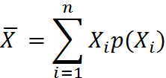

**Measurement of systematic Risk**

The systematic risk is measured by a statistical measure called Beta. Two statistical methods may be used for the calculation of Beta

1. Correlation Method

2. Regression Method

* Standard deviation method- It is the most common quantitative measure of risk of an asset. It considers every possible event and weight to its probability is assigned to each to its probability is assigned to each event. Standard deviation is a measure of dispersion around the expected or average mean value.

Correlation Method

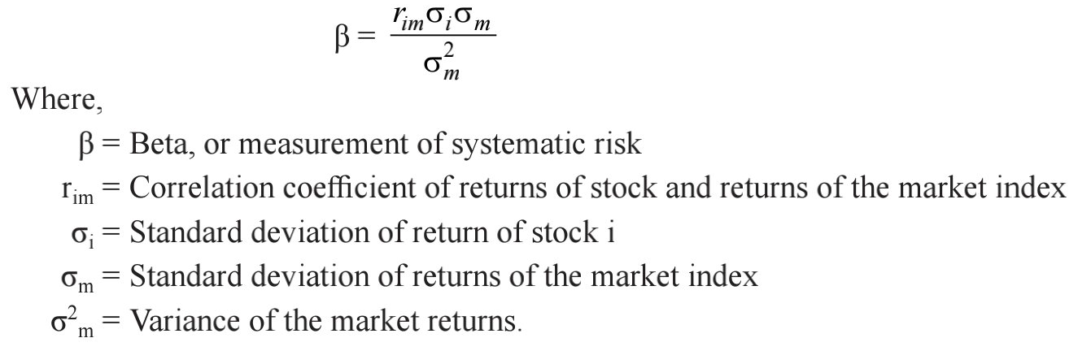

Regression method- The model postulates a linear relationship between a dependent variable and an independent variable. The Model helps to calculate the values of two constants namely α and β. α measure the value of dependent variable even when the independent variable has zero value. -β measure the change in the dependent variable in response to unit change in the independent variable.

Form of regression equation

* Y₌α +βX
* Y = Dependent variable
* X = Independent variable
* - β α are constants
* The formula for the calculation of alpha and Beta
* -α =Y̅ - βX̅

-β= n∑XY –(∑X)(∑Y)/ n∑ X2  - (∑X)2

* Y̅ = Mean value of the dependent variable scores
* X̅ = Mean value of the independent variable scores
* Y = Dependent variable scores
* X = Independent variable scores
* - n = Number of items

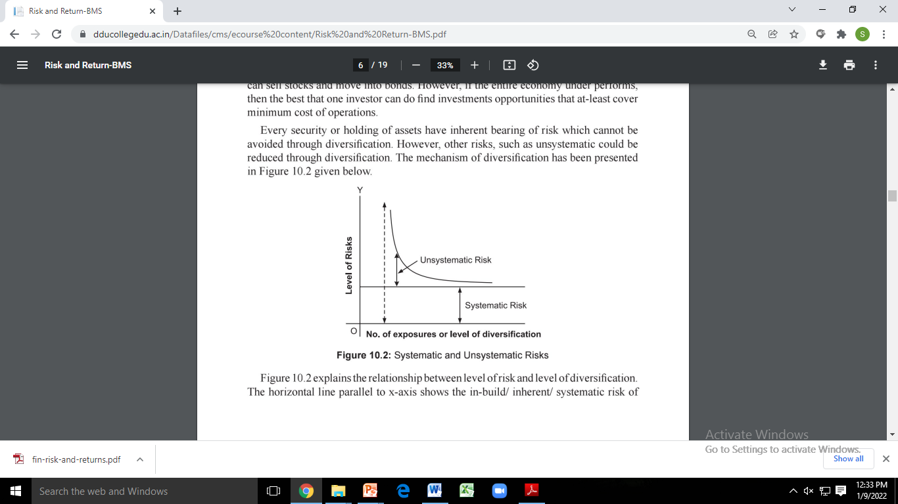

**Beta** is a statistical measure of the volatility of an individual security compared with the market as a whole. It is the relative tendency of a security’s returns to respond to overall market fluctuations. The average beta is 1.0, and a stock with a beta of 1.0 is said to have the same level of risk as that of the market in general. Securities with a beta less than 1.0 are considered less risky than the average stock and the market in general, for example, utility stocks. Securities with a beta greater than 1.0 are considered more risky than the average stock and the market in general, for example technology stocks. A zero-beta, such as a Treasury bill, is uncorrelated or independent of the market in general. Betas are estimated by running a regression of the returns (typically weekly returns) on a stock (dependent variable) with those on a market index (independent variable), such as the Standard and Poor’s 500. The slope of the regression line (coefficient of the independent variable) measures beta or the systematic risk estimate of the stock. Once individual stock betas are determined, the portfolio beta is easily calculated as the weighted average. Beta is the return of the individual security is taken as the dependent variable and the return of the market index is taken as the independent variable. The regression equation is represented as follows:

* Ri = α+βRm
* Ri = Return of the individual security
* Rm =Return of the market index
* - α = Estimated return of the security when the market is stationary
* -β change in the return of security in response to unit change
* -β measures the volatility of security’s returns relative to the market the larger the beta the more volatile the security.
* As the beta of 1 indicates a security of a average risk
* Greater than 1 has above the average risk

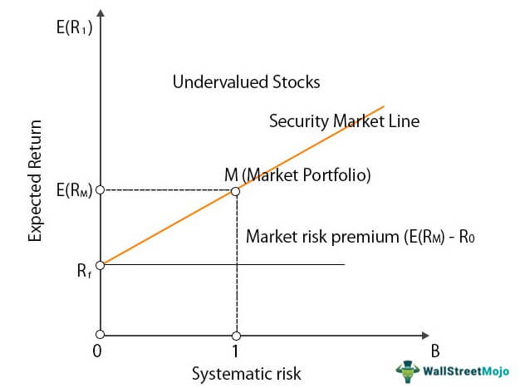

**CAPM (Capital Assets Pricing Model)**

It is used to quantify the relationship between the expected rate of return and the systematic risk of individual securities as well as portfolios. It states that the expected return on an investment is a function of

1.The time value of money (the reward for waiting)

2. A reward for taking on risk

3. The amount of risk

Assumptions of CAPM

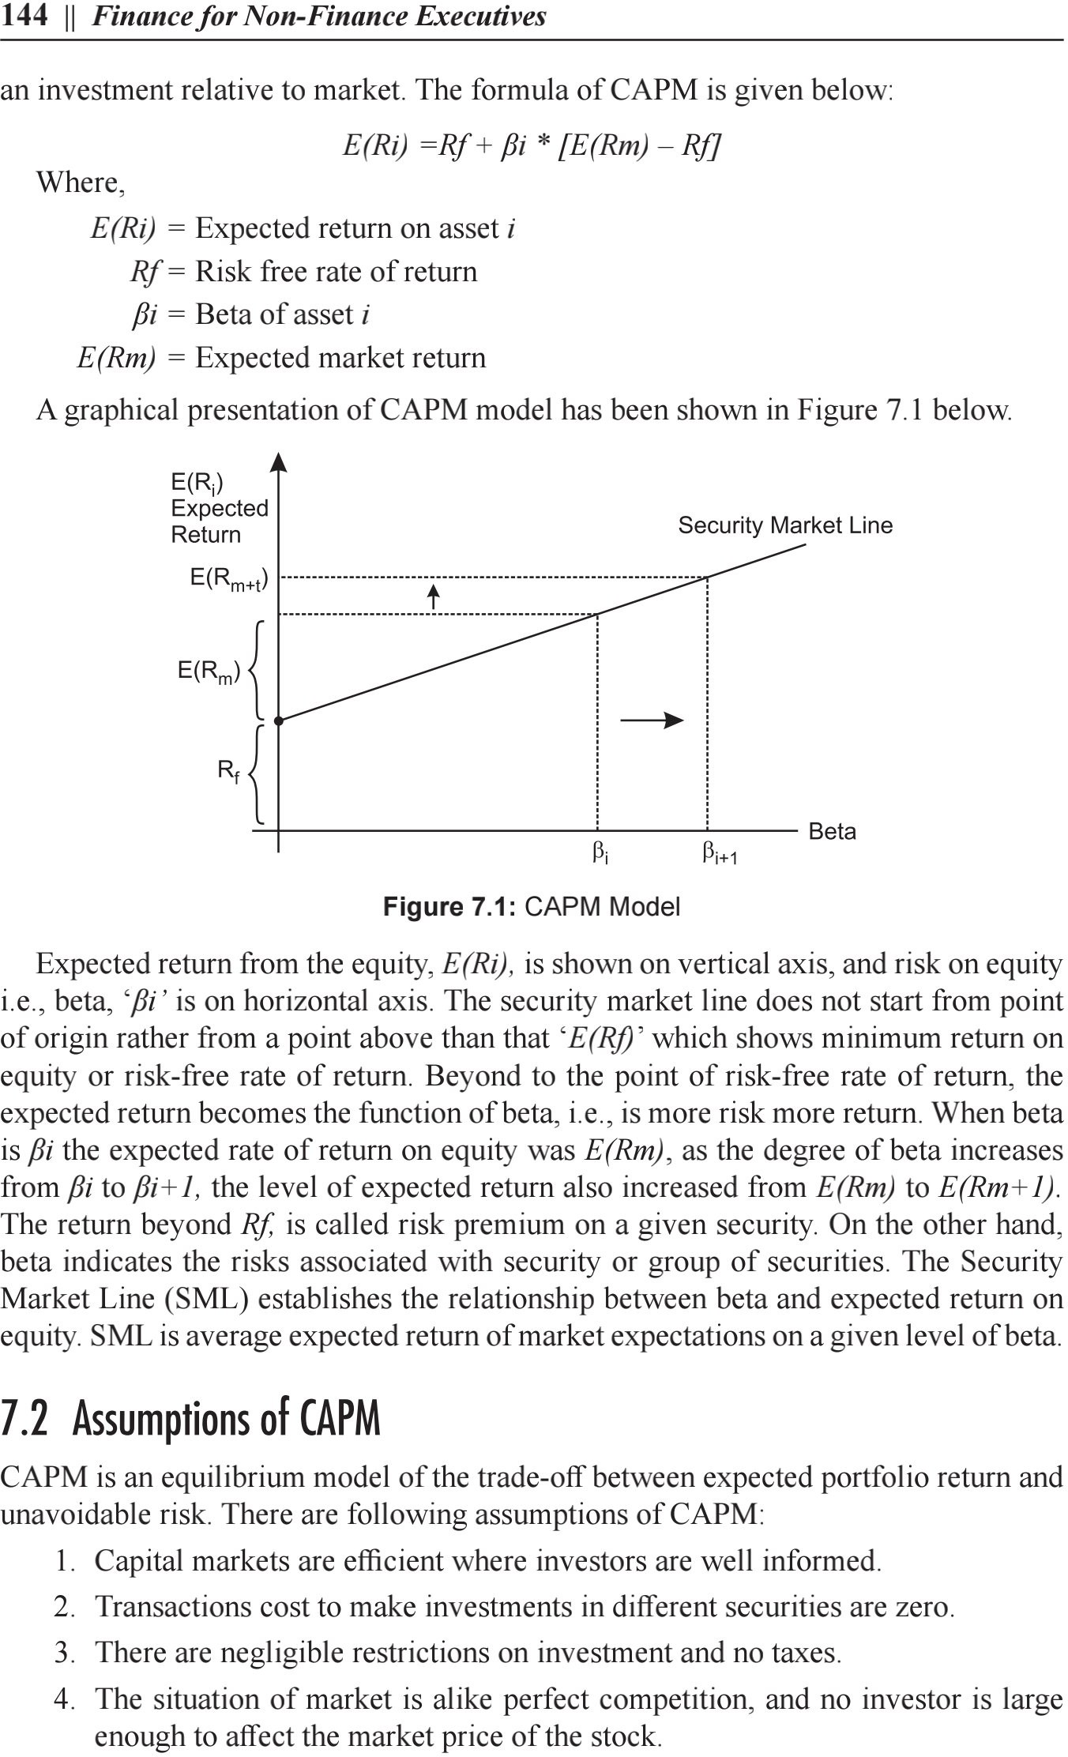

Return on an investment = Rf + (Rm – Rf)* beta

* SML tells about the market risk in an investment or identifies a point beyond which an investor may run into risk. It tells the relation between the required rate of return of security as a function of the non-diversifiable risk (or systematic risk).
* In an ideal scenario of market equilibrium, all the securities will fall on the SML. A security that is above the SML line is said to be underpriced. This is because it suggests that its return is more than what is needed to offset the systematic risk with that security. Similarly, security below the SML is overpriced. This is because it is unable to give the required return to compensate for the risk.So, we can say that SML eventually helps investors to identify over or underpriced securities.
* E(Ri) = Rf + βi [E(RM) – Rf]
* In the above security market line formula:
* E(Ri) is the expected return on the security
* Rf is the risk-free rate and represents the y-intercept of the SML
* βi is a non-diversifiable or systematic risk. It is the most crucial factor in SML. We will discuss this in detail in this article.
* E(RM) is expected to return on market portfolio M.
* E(RM) – Rfis known as Market Risk Premium
* CML, on the other hand, is a graphical representation that tells the rate at which the securities are providing a return. In simple words, it helps to determine the degree of profit an investor makes as per their investment. Or, we can say that CML shows the rate of returns on the basis of risk-free rates and the risk-level in a portfolio. In simple words, CML depicts a trade-off between the risk and return for efficient portfolios. This line represents the combination of portfolios that include the risk-free rate and risky assets. So, a portfolio on the SML would maximize the performance by optimizing the risk/return relationship.
* ERp = Rf + SDp * (ERm – Rf) /SDm

where,

* Expected Return of Portfolio
* Risk-Free Rate
* Standard Deviation of Portfolio
* Expected Return of the Market
* Standard Deviation of Market

Investor may be risk seeker, risk averse and risk neutral

* Risk seeker- investor who is willing to accept greater investment uncertainty and volatility in exchange for the potential of higher return
* Risk averse- investor who prefers lower returns with known risks rather than higher returns with unknown risk

Risk and return relationship- there is direct relationship between risk and return. An investment proposal involving low risk has low return while a proposal involving higher risk has higher return. Therefore, a finance manager is often required to trade off between the risk and return. A proper balance or combination is to be maintained between the risk and return by a finance manager in order to maximize the wealth of the shareholders in terms of market price of the share. Such a combination is called risk return trade off.

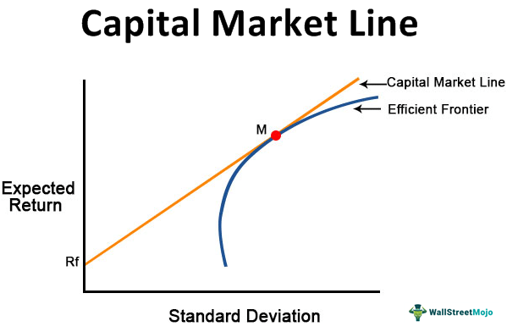

**Time value money**

**Compounding and Discounting**

Time value of money- The time value of money is the concept that money available at the present time is worth more than the identical sum in the future due to its potential earning capacity. The simple concept of time value of money is that he value of the money received today is more than the value of same amount of money received after a certain period. In other words, money received in the future is not as valuable as money received today, the sooner one receives money the better it is.

**Reason for time preference of money**

* The future is always uncertain and involves risk.
* People generally prefer to use their money for satisfying their present needs in buying more food, or clothes or another car, than deferring in future.
* Money has time value because of the opportunities available to invest money received at earlier dates at some interest or otherwise to enhance future earnings**.**

**Techniques of time value of money**

* Compounding technique – this time preference for money encourages a person to receive money at present instead of waiting for future
* Discounting- present value shows what the value is today of some future sum of money. The present value of money to be received in future will always be less.

Annuities are level streams of payments. Each payment is the same amount and occurs at a regular interval. Annuities are common in business. They can arise in loans, retirement plans, leases, insurance settlements, tax-related calculations, and so forth. Sometimes, one may be curious to learn how much a recurring stream of payments will grow to after a number of periods. This is called the future value of an annuity.

When cash flows occur at the end of each period the annuity is called a regular annuity or a deferred annuity. Is the cash flows occur at the beginning of each period the annuity is called annuity due.

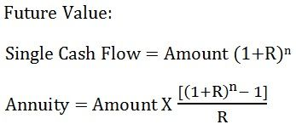

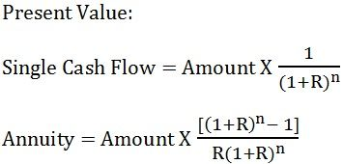

|  |  |  |
| --- | --- | --- |
| BASIS | COMPOUNDING | DISCOUNTING |
| Meaning | The method used to determine the future value of present investment is known as Compounding. | The method used to determine the present value of future cash flows is known as Discounting. |
| Concept | If we invest some money today, what will be the amount we get at a future date. | What should be the amount we need to invest today, to get a specific amount in future. |
| Use of | Compound interest rate. | Discount rate |
| Known | Present Value | Future Value |
| Factor | Future Value Factor or Compounding Factor | Present Value Factor or Discounting Factor |
| Formula | FV = PV (1 + r)^n | PV = FV / (1 + r)^n |

**Capital Budgeting**

Capital budgeting is a company’s formal process used for evaluating potential expenditures or investments that are significant in amount. It involves the decision to invest the current funds for addition, disposition, modification or replacement of fixed assets. The large expenditures include the purchase of fixed assets like land and building, new equipments, rebuilding or replacing existing equipments, research and development, etc. The large amounts spent for these types of projects are known as capital expenditures. Capital Budgeting is a tool for maximizing a company’s future profits since most companies are able to manage only a limited number of large projects at any one time.

Capital budgeting usually involves calculation of each project’s future accounting profit by period, the cash flow by period, the present value of cash flows after considering time value of money, the number of years it takes for a project’s cash flow to pay back the initial cash investment, an assessment of risk, and various other factors. Capital budgeting is the process of making investment decisions in capital expenditure.

A capital expenditure may be defined as an expenditure the benefits of which are expected to be received over period of time exceeding one year

**Need of capital budgeting**

* Whether or not funds should be invested in long term projects such of an industry, purchase of plant and machinery.
* Analyze the proposal for expansion or creating additional capacities
* To decide the replacement of permanent assets such as building and equipment's.
* To make financial analysis of various proposals regarding capital investments so as to choose the best out of many alternative proposals

**CAPITAL BUDGETING PROCESS:**

**Project identification and generation:** The first step towards capital budgeting is to generate a proposal for investments. There could be various reasons for taking up investments in a business. It could be addition of a new product line or expanding the existing one. It could be a proposal to either increase the production or reduce the costs of outputs.

**Project Screening and Evaluation:** This step mainly involves selecting all correct criteria’s to judge the desirability of a proposal. This has to match the objective of the firm to maximize its market value. The tool of time value of money comes handy in this step. Also the estimation of the benefits and the costs needs to be done. The total cash inflow and outflow along with the uncertainties and risks associated with the proposal has to be analyzed thoroughly and appropriate provisioning has to be done for the same.

**Project Selection:** There is no such defined method for the selection of a proposal for investments as different businesses have different requirements. That is why, the approval of an investment proposal is done based on the selection criteria and screening process which is defined for every firm keeping in mind the objectives of the investment being undertaken.

Once the proposal has been finalized, the different alternatives for raising or acquiring funds have to be explored by the finance team. This is called preparing the capital budget. The average cost of funds has to be reduced. A detailed procedure for periodical reports and tracking the project for the lifetime needs to be streamlined in the initial phase itself. The final approvals are based on profitability, Economic constituents, viability and market conditions.

**Implementation:** Money is spent and thus proposal is implemented. The different responsibilities like implementing the proposals, completion of the project within the requisite time period and reduction of cost are allotted. The management then takes up the task of monitoring and containing the implementation of the proposals.

**Performance review:** The final stage of capital budgeting involves comparison of actual results with the standard ones. The unfavorable results are identified and removing the various difficulties of the projects helps for future selection and execution of the proposals.

**CAPITAL BUDGETING DECISIONS**

The crux of capital budgeting is profit maximization. There are two ways to it; either increase the revenues or reduce the costs. The increase in revenues can be achieved by expansion of operations by adding a new product line. Reducing costs means representing obsolete return on assets.

**Accept / Reject decision** – If a proposal is accepted, the firm invests in it and if rejected the firm does not invest. Generally, proposals that yield a rate of return greater than a certain required rate of return or cost of capital are accepted and the others are rejected. All independent projects are accepted. Independent projects are projects that do not compete with one another in such a way that acceptance gives a fair possibility of acceptance of another.

**Mutually exclusive project decision** – Mutually exclusive projects compete with other projects in such a way that the acceptance of one will exclude the acceptance of the other projects. Only one may be chosen. Mutually exclusive investment decisions gain importance when more than one proposal is acceptable under the accept / reject decision. The acceptance of the best alternative eliminates the other alternatives.

**Capital rationing decision** – In a situation where the firm has unlimited funds, capital budgeting becomes a very simple process. In that, independent investment proposals yielding a return greater than some predetermined level are accepted. But actual business has a different picture. They have fixed capital budget with large number of investment proposals competing for it. Capital rationing refers to the situation where the firm has more acceptable investments requiring a greater amount of finance than that is available with the firm. Ranking of the investment project is employed on the basis of some predetermined criterion such as the rate of return. The project with highest return is ranked first and the acceptable projects are ranked thereafter.

**FACTORS AFFECTING CAPITAL BUDGETING**

|  |  |  |
| --- | --- | --- |
| Availability of Funds |  | Working Capital |
| Structure of Capital |  | Capital Return |
| Management decisions |  | Need of the project |
| Accounting methods |  | Government policy |
| Taxation policy |  | Earnings |
| Lending terms of financial institutions |  | Economic value of the project |

**IMPORTANCE OF CAPITAL BUDGETING**

1) Long term investments involve risks: Capital expenditures are long term investments which involve more financial risks. That is why proper planning through capital budgeting is needed.

2) Huge investments and irreversible ones: As the investments are huge but the funds are limited, proper planning through capital expenditure is a pre-requisite. Also, the capital investment decisions are irreversible in nature, i.e. once a permanent asset is purchased its disposal shall incur losses.

3) Long run in the business: Capital budgeting reduces the costs as well as brings changes in the profitability of the company. It helps avoid over or under investments. Proper planning and analysis of the projects helps in the long run.

**SIGNIFICANCE OF CAPITAL BUDGETING**

* Capital budgeting is an essential tool in financial management
* Capital budgeting provides a wide scope for financial managers to evaluate different projects in terms of their viability to be taken up for investments
* It helps in exposing the risk and uncertainty of different projects
* It helps in keeping a check on over or under investments
* The management is provided with an effective control on cost of capital expenditure projects
* Ultimately the fate of a business is decided on how optimally the available resources are used

**Techniques of capital budgeting**

**NPV method**- This is one of the widely used methods for evaluating capital investment proposals. In this technique the cash inflow that is expected at different periods of time is discounted at a particular rate. The present values of the cash inflow are compared to the original investment. If the difference between them is positive (+) then it is accepted or otherwise rejected. This method considers the time value of money and is consistent with the objective of maximizing profits for the owners. However, understanding the concept of cost of capital is not an easy task.

The net present value is calculated by taking the difference between the present value of cash inflows and the present value of cash outflows over a period of time. The investment with a positive NPV will be considered. In case there are multiple projects, the project with a higher NPV is more likely to be selected.Net present value (NPV) is the excess of the present value (PV) of cash inflows generated by the project over the amount of initial investment (I).

* NPV is positive the project can be accepted
* NPV is negative the project can be rejected
* The project which gives the highest positive NPV should be selected

Advantages of Net Present Value (NPV)

The net present value of a project in business guides the finance team for making wise decisions. Let us now go through the numerous benefits it has for the company, in the long run:

* Simple to Use: The net present value method is easy to apply to a real business project if the cash flows and discount rate are known.
* Provides Time Value of Money: This method takes into consideration the effect of inflation on the future profitability of the project, thus estimating the time value of money.
* Customization: In NPV, the discount rate can be adjusted according to the risk prevailing in the industry, along with various other factors, to obtain an appropriate output.
* Determines Investment Value: The earnings throughout the project’s life span can be acquired by using the NPV method, which facilitates the company to know the future value of a specific investment.
* Comparable: It facilitates the comparison of values generated in the future, by two or more similar projects to find out the most feasible option.
* Comprehensive Method: It finds the present value of a project by examining the effect of various factors like risk, cash outflows, and inflows.
* Measures Profitability: It is one of the most proficient methods of determining the actual profitability of a project in its lifetime.
* Identifies Risk: In the absence of NPV, the managers would fail to estimate the risk of loss or meagre profitability in case of a long-lived project. It is otherwise possible by identifying the project with negative or zero NPV.
* Reinvestment Assumption: The net present value is quite logical since, here the cash flows are not expected to be reinvested in the financial market, as done in the internal rate of return.

Disadvantages of Net Present Value

The biggest disadvantage to the net present value (NPV) method is that it requires some guesswork about the firm’s cost of capital. Assuming a cost of capital that is too low will result in making suboptimal investments. Assuming a cost of capital that is too high will result in forgoing too many good investments.

The net present value (NPV) is an effective means of evaluating a project’s profitability; however, it has certain drawbacks. These are as follows:

* Forecasting Errors: While assessing the viability of a long-lived project, the estimation of cash flows may not be that accurate for the later years.
* Minimum Contribution to Shareholder’s Value: The shareholder’s value maximization is the result of the overall growth of a company, whereas a high NPV contributes little towards it.
* Depends Upon Discount Rates: Since this method is based on discount rates, even a slight change may result in an entirely different NPV.
* Neglects Sunk Cost: The sunk cost like research and development, trial, etc. incurred before the project starts, is mostly high. This cost is wholly ignored under the computation of NPV.
* No Effect on EPS and ROE: Often, the projects with high NPV but the short duration may not enhance the earning per share and return on equity.
* Incomparable for Differing Project Size: The concept of capital rationing is applied in NPV; therefore, the projects which do not lie under the capital budget limit cannot be compared under this method.

**Payback period method**-As the name suggests, this method refers to the period in which the proposal will generate cash to recover the initial investment made. It purely emphasizes on the cash inflows, economic life of the project and the investment made in the project, with no consideration to time value of money. Through this method selection of a proposal is based on the earning capacity of the project. With simple calculations, selection or rejection of the project can be done, with results that will help gauge the risks involved. However, as the method is based on thumb rule, it does not consider the importance of time value of money and so the relevant dimensions of profitability. PBmeasures the length of time required to recover the amount of initial investment.

In this technique, the entity calculates the time period required to earn the initial investment of the project or investment. The project or investment with the shortest duration is opted for. It is the number of years it takes for the firm to recover the original investment by net returns before depreciation, after taxes

**Payback period = Cash outlay (investment) / Annual cash inflow**

## Merits of Payback Period method

1. It is very simple to understand and easy to calculate.

2. It requires less cost, time and labour when compared to other methods of capital budgeting.

3. This method reduces or avoids the loss through obsolescence since shorter payback period is preferred to longer payback period.

4. This method is mostly suitable to a company which has less amount of cash in hand and a company whose liquidity position is very weak.

5. It gives much importance to the speedy recovery of investment in capital assets.

## Demerits of Payback Period

1. A slight change made in the labour cost or cost of maintenance, there is a much change in its earnings and affects the payback period.

2. This method ignores the short term solvency or liquidity of the business concern.

3. It ignores capital wastage and economic life by restricting consideration to the project’s gross earnings.

4. The time value of money is not considered in the payback period method.

5. It overlooks the cost of capital which is a main factor in sound capital budgeting decision. This method does not consider the cash inflows arising after the payback period.

6. This could be misleading in capital budgeting decisions.

7. This method fails to measure the productivity of capital expenditure plan because it does not attempt to measure the return on investment.

8. This method does not consider full earnings or full savings of the capital expenditure plan i.e. savings or earnings available during whole economic life of the project.

9. This method also fails to assign proper weightage to the unevenness of rate of profit of various projects.

10. It may be difficult to determine minimum acceptable payback period. Generally, it is a subjective decision.

11. This method treats the each asset individually in isolation with other assets. But, in practice, it is not feasible.

**Accounting rate of return method (ARR)-** This method helps to overcome the disadvantages of the payback period method. The rate of return is expressed as a percentage of the earnings of the investment in a particular project. It works on the criteria that any project having ARR higher than the minimum rate established by the management will be considered and those below the predetermined rate are rejected.

This method takes into account the entire economic life of a project providing a better means of comparison. It also ensures compensation of expected profitability of projects through the concept of net earnings. However, this method also ignores time value of money and doesn’t consider the length of life of the projects. Also it is not consistent with the firm’s objective of maximizing the market value of shares.

This technique uses the accounting information revealed by the financial statements to measure the profitability of an investment proposal. In this technique, the total net income of the investment is divided by the initial or average investment to derive at the most profitable investment.

Merits of Using ARR

* Simplicity − The ARR method is one of the easiest methods to evaluate an investment. Unlike NPV and IRR methods, it does not involve critical and complex computations. Moreover, being simple to understand, ARR is widely used for audiences who have less knowledge of finance. Simplicity makes ARR the preferred choice of investment evaluation for non-finance managers.
* Use of accounting data − Unlike NPV and IRR methods, ARR does not require considering cash flows. ARR can be calculated right from accounting data. As accounting data are readily available, ARR calculation is one of the easiest ways to evaluate an investment. Moreover, as accounting data is a true reflection of a company’s performance, ARR is quite appropriate in evaluating a firm’s performance based on given investments.
* Accounting profitability − ARR method consists of the entire stream of income and profitability throughout the project. Therefore, it provides a complete picture of the profitability of an investment project. Using accounting profitability offers the companies the flexibility to focus on more profitable investment options, thereby providing an easy route to evaluate the investments.

Demerits of Using ARR

Here are some of the demerits of using ARR −

* Cash flows are ignored − ARR uses profitability as the measure of investment evaluation ignoring the cash flows. As profitability is an incomplete measure of true investment evaluation, ARR is flawed in some cases of investment. Accounting profits are usually based on some arbitrary assumptions, and it may also involve non-cash items. It is therefore inappropriate to rely on ARR completely as a standalone tool to evaluate an investment project.
* Time value is ignored − ARR method completely ignores the time value of money which states that a certain amount of money at present is worth more than the same amount of money in the future. The lack of adjustment of the time value of money makes ARR an inappropriate process to evaluate investments.
* Arbitrary cut-off − Most of the companies that prefer ARR as an evaluation technique use an arbitrary cut-off yardstick to restrict the projects. Usually, the yardstick is the firm’s current return on its assets which is also known as book value. Due to this, growth companies earning very big rates on the existing assets may reject profitable projects, while smaller companies with fewer returns from assets may choose less profitable projects.

ARR= Average income/Average Investment

**Discounted cash flow method-** discounted cash flow technique calculates the cash inflow and outflow through the life of an asset. These are then discounted through a discounting factor. The discounted cash inflows and outflows are then compared. This technique takes into account the interest factor and the return after the payback period.

**Internal Rate of Return (IRR)-** This is defined as the rate at which the net present value of the investment is zero. The discounted cash inflow is equal to the discounted cash outflow. This method also considers time value of money. It tries to arrive to a rate of interest at which funds invested in the project could be repaid out of the cash inflows. However, computation of IRR is a tedious task.

It is called internal rate because it depends solely on the outlay and proceeds associated with the project and not any rate determined outside the investment.

* Accept if IRR > K
* Reject if IRR < K
* May accept or reject if IRR = K
* Where k is cost of capital

Merits of IRR Method

Following are the merits of using IRR as an investment evaluation method −

* Time value of money − IRR considers the time value of money. It states that a rupee today will be worth more than a rupee tomorrow. By considering the time value of money, IRR makes a correct assumption about profitability. In fact, IRR saves enough wealth by considering the time value of money.
* Measurement of profitability − IRR considers all cash flows to correctly measure the profitability of an investment proposal. This provides a comprehensive measurement of profitability as future cash inflow and outflow estimates are considered. By including cash flow features, IRR takes the view of the entire life of a project to measure profitability in the long-term future.
* Increase in Shareholders’ value − IRR aims to maximize the shareholders’ wealth by considering all aspects related to shareholders’ wealth maximization rules. It is by large one of the most promising features of IRR because every investment needs to prioritize shareholders’ wealth creation and maximization.

Demerits of IRR Method

Following are some of the demerits of using IRR as an investment evaluation method −

* Multiple Rates of Return − According to IRR, an investment project may have different and multiple rates of return. Having more than one rate not only increases the complexity of the calculation, but it also creates a dilemma where choosing the best project becomes critical. Therefore, having multiple rates of returns is one of the prominent demerits of IRR.
* Failing to identify the best project in case of mutually exclusive ones − IRR may fail to identify the best project if there are mutually exclusive projects on the horizon. Not being able to identify the better project means there may be large losses in the future for which IRR estimation becomes flawed and non-competitive in nature.
* Value additivity does not hold good − Unlike NPV, value additivity doesn’t hold good for IRR. This means that the IRR for a larger project need not be equal to the sum of all smaller subsidiary projects. In addition of smaller projects’ IIRs are incapable to produce the IRR of the larger project, it is not possible to calculate the value of IRR of the larger projects even if we know the smaller IRRs. This creates a big issue in applying and calculating IRRs in both theory and practice.

**Profitability Index (PI)-** t is the ratio of the present value of future cash benefits, at the required rate of return to the initial cash outflow of the investment. It may be gross or net, net being simply gross minus one. The profitability index is the ratio of the total PV of future cash inflows to the initial investment, that is, ***PV/I.*** This index is used as a means of ranking projects in descending order of attractiveness. If the profitability index is greater than 1, then accept.

Profitability Index is the ratio of the present value of future cash flows of the project to the initial investment required for the project.The formula to calculate profitability index (PI) or benefit cost (BC) ratio is as follows.

PI = PV cash inflows/Initial cash outlay A,

## Merits of Profitability Index Method

### Recognition of Time Value of Money- Like NPV, PI also considers the time value of money. This leads to better recognition of profitability as the future incomes are taken to be less than the equivalent present incomes. By taking the time value of money into consideration, PI maximizes the true profitability of an investment proposal.

Time value of money also helps in determining the long-term goals as well as capital budgeting measures that require sound policies about future cash flows.

### Value Maximization- The PI process is consistent with the shareholders’ value maximization principle. The projects that have positive PI values that are more than 1 will have positive NPVs. According to the rules of thumb, projects with positive NPV are undertaken by firms. So when the PI is positive and more than 1, it will be undertaken by the company, and shareholders’ wealth will be maximized. This is a very important merit of PI because shareholders’ wealth maximization is the primary goal of all investment strategies.

## Demerits of Profitability Index Method

### Relative Measure of Profitability- In the case of PI, the ratio of the present value of cash inflows to the initial value of cash outflows gives a relative measure of the profitability calculated by PI. Therefore, it is an insufficient measure of profitability. PI can only assume true profitability as it is related to initial cash outflow and not with all outflows that occur in the future.

### Cash flow and discount rate calculation- Like NPV and IRR, PI also considers cash flows and discount rates which are impossible to estimate accurately. Therefore, although theoretically sound, PI is not far from flaws in practice. As the determination of cash flows in the future cannot be completely accurate, the value of profit measured by PI cannot be free from flaws. The same statement holds good for discount rate calculations.

## Problem 1

The [**cost**](https://learn.financestrategists.com/explanation/cost-accounting/what-is-cost-and-its-types/) of a project is Rs50,000 and it generates cash inflows of Rs20,000, Rs15,000, Rs25,000, and Rs10,000 over four years.

**Required:**Using the present value index method, appraise the profitability of the proposed investment, assuming a 10% rate of discount.

### Solution

The first step is to calculate the present value and profitability index.

|  |  |  |  |
| --- | --- | --- | --- |
| **Year** | **Cash Inflows** | **Present Value Factor** | **Present Value** |
|  | Rs | **@10%** | rs |
| 1 | 20,000 | 0.909 | 18,180 |
| 2 | 15,000 | 0.826 | 12,390 |
| 3 | 25,000 | 0.751 | 18,775 |
| 4 | 10,000 | 0.683 | 6,830 |
|  |  |  | **56,175** |

Total present value = Rs56,175  
Less: intial outlay = Rs50,000  
Net present value = Rs 6,175

**Profitability Index (gross) = Present value of cash inflows / Intial cash outflow**  
= 56,175 / 50,000  
= 1.1235

Given that the profitability index (PI) is greater than 1.0, we can accept the proposal.

**Net Profitability = NPV / Initial cash outlay**  
= 6,175 / 50,000 = 0.1235  
N.P.I. = 1.1235 – 1 = 0.1235

Given that the net profitability index (NPI) is positive, we can accept the proposal.

## Problem 2

A company is considering whether to [**purchase**](https://learn.financestrategists.com/finance-terms/purchases/) a new machine. Machines A and B are available for $80,000 each. Earnings after taxation are as follows:

|  |  |  |
| --- | --- | --- |
| **Year** | **Machine A** | **Machine B** |
|  | Rs | Rs |
| 1 | 24,000 | 8,000 |
| 2 | 32,000 | 24,000 |
| 3 | 40,000 | 32,000 |
| 4 | 24,000 | 48,000 |
| 5 | 16,000 | 32,000 |

**Required:**Evaluate the two alternatives using the following: (a) payback method, (b) [**rate of return**](https://learn.financestrategists.com/finance-terms/rate-of-return/) on investment method, and (c) net present value method. You should use a [**discount rate**](https://learn.financestrategists.com/finance-terms/discount-rate/) of 10%.

### Solution

**(a) Payback method**

24,000 of 40,000 = 2 years and 7.2 months

Payback period:

**Machine A:** (24,000 + 32,000 + 1 **3/5**of 40,000) = 2 3/5years.  
**Machine B:** (8,000 + 24,000 + 32,000 + 1/3 of 48,000) = 3 1/3years.

According to the payback method, Machine A is preferred.

**(b) Rate of return on investment method**

|  |  |  |
| --- | --- | --- |
| **Particular** | **Machine A** | **Machine B** |
| Total Cash Flows | 1,36,000 | 1,44,000 |
| Average Annual Cash Flows | 1,36,000 / 5 = Rs27,000 | 1,44,000 / 5 = Rs28,800 |
| Annual Depreciation | 80,000 / 5 = Rs16,000 | 80,000 / 5 = RS16,000 |
| Annual Net Savings | 27,200 – 16,000 = RS11,200 | 28,800 – 16,000 = RS12,800 |
| Average Investment | 80,000 / 2 = RS40,000 | 80,000 / 2 = RS40,000 |
| ROI = (Annual Net Savings / Average Investments) x 100 | (11,200 / 40,000) x 100 | (12,800 / 40,000) x 100 |
|  | = 28% | = 32% |

According to the rate of return on investment (ROI) method, Machine B is preferred due to the higher ROI rate.

**(c) Net present value method**

The idea of this method is to calculate the present value of cash flows.

|  |  |  |  |  |  |
| --- | --- | --- | --- | --- | --- |
| **Year** | **Discount Factor** | **Machine A** | | **Machine B** | |
|  | **(at 10%)** | **Cash Flows (RS)** | **P.V (RS)** | **Cash Flows (RS)** | **P.V (RS)** |
| 1 | .909 | 24,000 | 21,816 | 8,000 | 7,272 |
| 2 | .826 | 32,000 | 26,432 | 24,000 | 19,824 |
| 3 | .751 | 40,000 | 30,040 | 32,000 | 24,032 |
| 4 | .683 | 24,000 | 16,392 | 48,000 | 32,784 |
| 5 | .621 | 16,000 | 9,936 | 32,000 | 19,872 |
|  |  | **1,36,000** | **1,04,616** | **1,44,000** | **1,03,784** |

Net Present Value = Present Value – Investment  
Net Present Value of Machine A: $1,04,616 – 80,000 = RS24,616  
Net Present Value of Machine B: $1,03,784 – 80,000 = $23,784

According to the net present value (NPV) method, Machine A is preferred because its NPV is greater than that of Machine B.

**Cost of capital**

**Module III**

The cost of capital is the minimum rate of return required on the investment projects to keep the market value per share unchanged.

In other words, the cost of capital is simply the rate of return the funds used should produce to justify their use within the firm in the light of the wealth maximisation objective. Cost of capital is vital part of investment decision as it is used to measure the value of investment proposal provided by the business concern. It is used as a discount rate to determine the present value of future cash flows related with capital projects. Cost of capital is also termed as cut-off rate, target rate, hurdle rate and required rate of return. When the companies are using different sources of finance, the finance manager must take vigilant decision with regard to the cost of capital; because it is closely associated with the value of the firm and the earning capacity of the firm.

**Future cost and Historical cost:**

It is commonly known that, in decision-making, the relevant costs are future costs are not the historical costs. The financial decision-making is no exception. It is future cost of capital which is significant in making financial decisions.

**Specific cost and combined cost:**

The cost of each component of capital (ex-common shares, debt etc.,) is known as specific cost of capital. The combined or composite cost of capital is an inclusive: cost of capital from all sources. It is, thus, the weighted average cost of capital.

**Explicit cost and implicit cost:**

The explicit cost of capital is the internal rate of return of the financial opportunity and arises when the capital is raised. The implicit of capital arises when the firm considers alternative uses of the funds rained. The methods of calculating the specific costs of different sources of funds are discussed.

**1. Cost of debt:**

It is relatively easy to calculate cost of debt, it is rate of return or the rate of interest specified at the time of debt issue. When a bond or debenture is issued at full face value and to be redeemed after some period, then the before tax cost of debt is simply the normal rate of interest.

Before tax cost of debt, Kd = Interest/ Principal

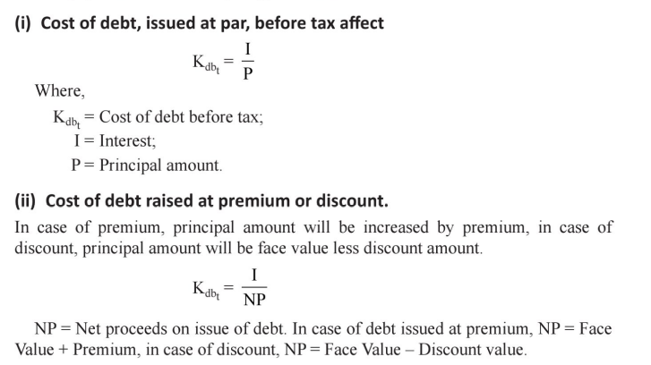

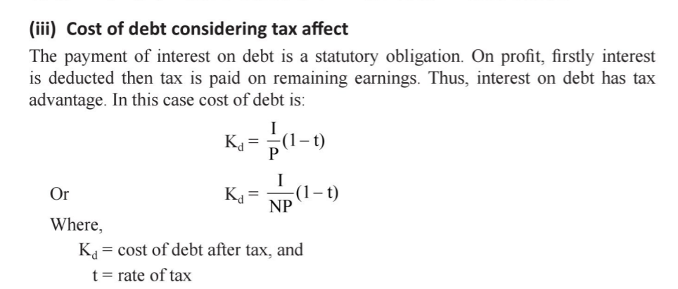

**2. Cost of preference capital:** The measurement of the cost of preference capital poses some conceptual difficulty. In the case of debt, there is a binding legal obligation on the firm to pay interest and the interest constitutes the basis to calculate the cost of debt.

However, when reference to the preference capital, it may be stated that the payment of dividends on preference capital is not legally binding on the firm and even if the dividends are paid, it is not a charge on earnings, rather it is a distribution or appropriation of earnings to a class of owners. It may, therefore, be concluded, that the dividends on preference capital do not constitute cost. This is not true.

The cost of preference capital is a function of the dividend expected by investors; preference capital is never issued with an intention not to pay dividends. Although it is not legally binding upon the firm to pay dividends on preference capital, yet it is generally paid when the firm makes sufficient profits.

The preference share may be treated as a perpetual security it is irredeemable. Thus, its cost is given by the following equation.

Where Kp is the cost of preference share, Dp represents the fixed dividend per preference share and P is the price per- preference share.

#### 3. Cost of equity capital:

It is sometimes argued that tine equity capital is free of cost. This is not true. The reason for advancing such an argument is that it is not legally binding on the company to pay dividends to the common shareholders. Also, unlike the interest rate on debt or the rate of dividend on preference capital, the dividend rate to the common shareholders is not fixed. However, the shareholders invest their money in common shares with an expectation of receiving dividends.

The market value of the share depends on the dividends expected by the shareholders. Therefore, the required rate of return which equates the present value of the expected dividends with the market value of share is the equity capita).

For the purpose of measuring the cost of equity, the equity capital will be divided into two parts a) external equity b) retained earnings.

**a) External equity:**

The minimum rate of return which is required on the new investment, financed by the new issue of common shares, to keep the market value of the share unchanged is the cost of new issue of common shares (or external equity).

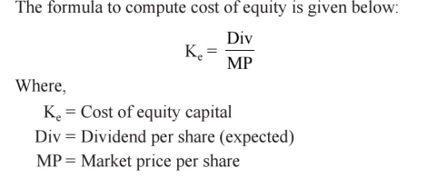



**b) Retained earnings:**

The companies are not required to pay any dividends on retained earnings. Therefore, it is sometimes observed that this source of finance is cost free. But retained earnings is the dividend foregone by the share holders.

**The cost of retained earnings is measured by the following equation:**

Kr = D/Po + g

Where Kr= Cost of retained earnings

D = Dividend

g = growth rate

Po =Market price of the share

### **Weighted Average Cost of Capital (WACC)**

Most of the time, we also use WACC in place of cost of capital because of its frequent and vast utilization especially when evaluating existing or new projects. WACC, as the term itself suggests, is the weighted average of all types of capital present in the capital structure of a company. Assuming these two types of capital in the capital structure i.e. equity and debt, we can [calculate the WACC](https://efinancemanagement.com/investment-decisions/wacc-calculation) the following formula:

WACC = Weight of Equity * Cost of Equity + Weight of Debt * Cost of Debt.





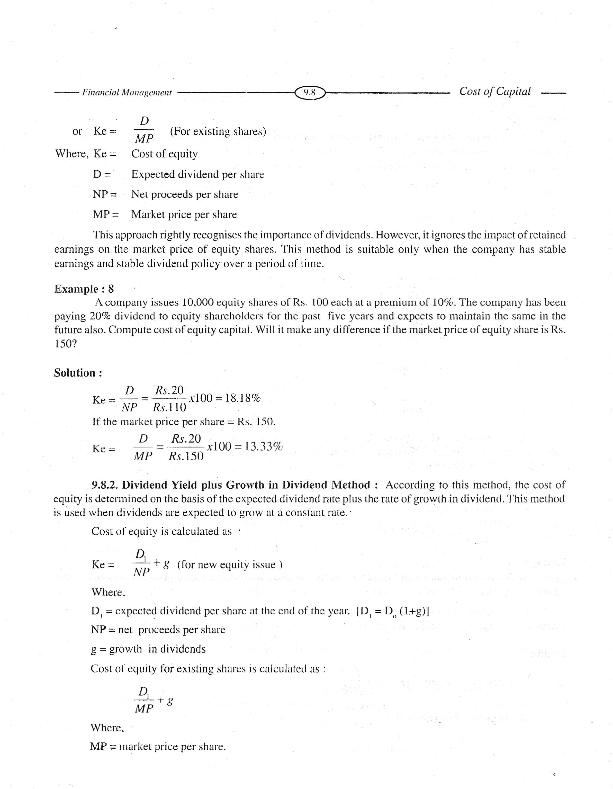



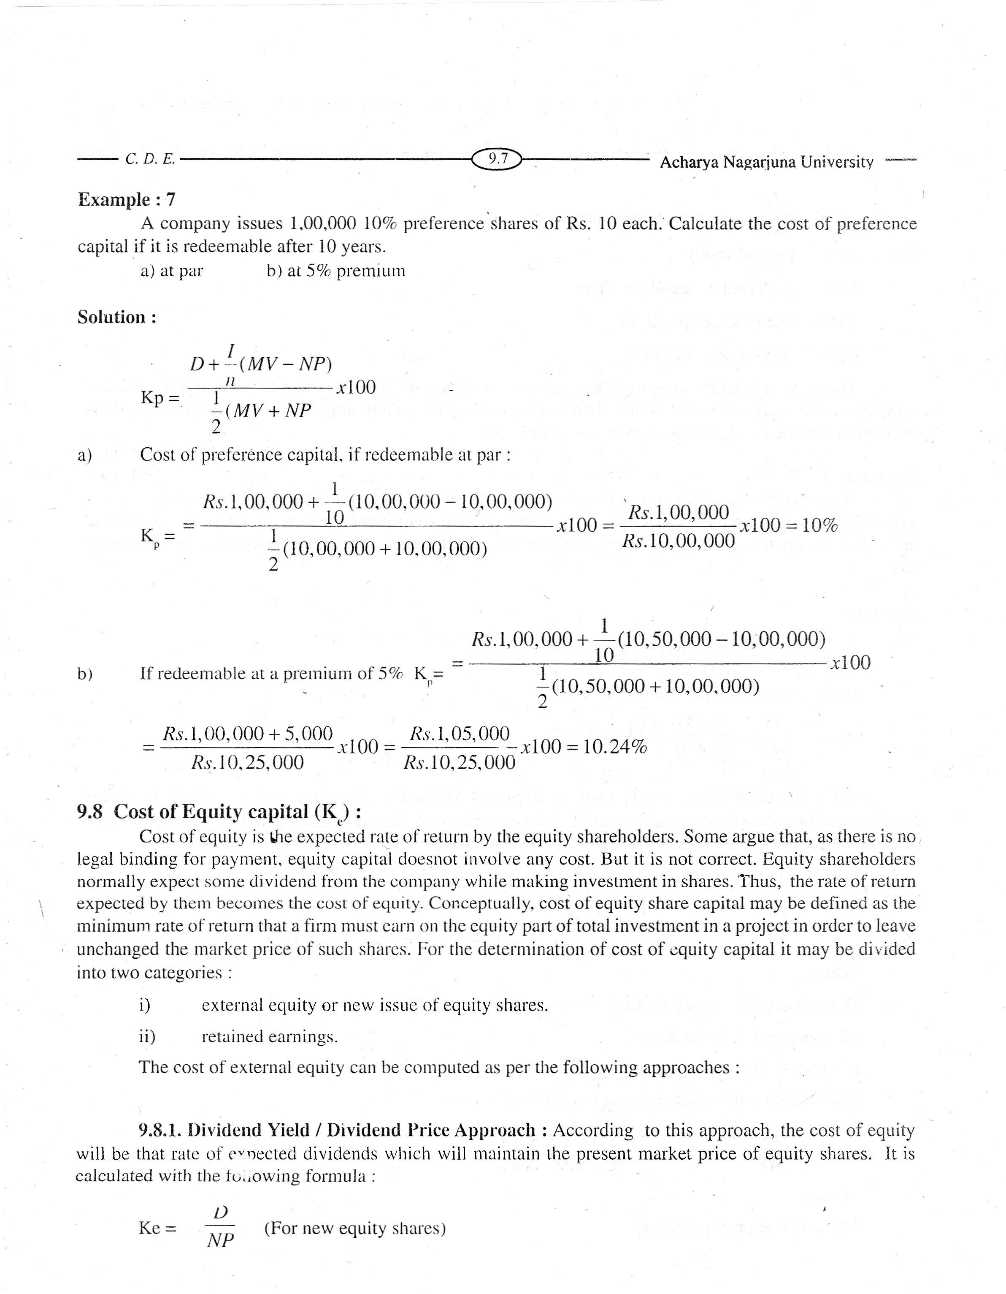

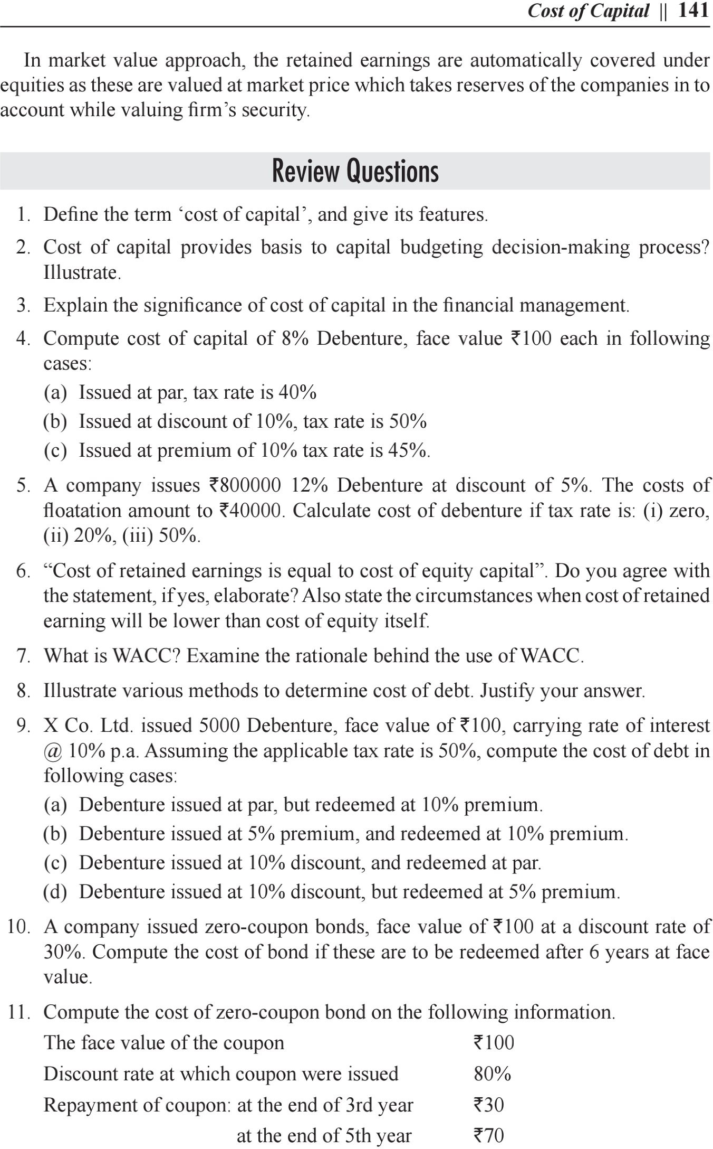

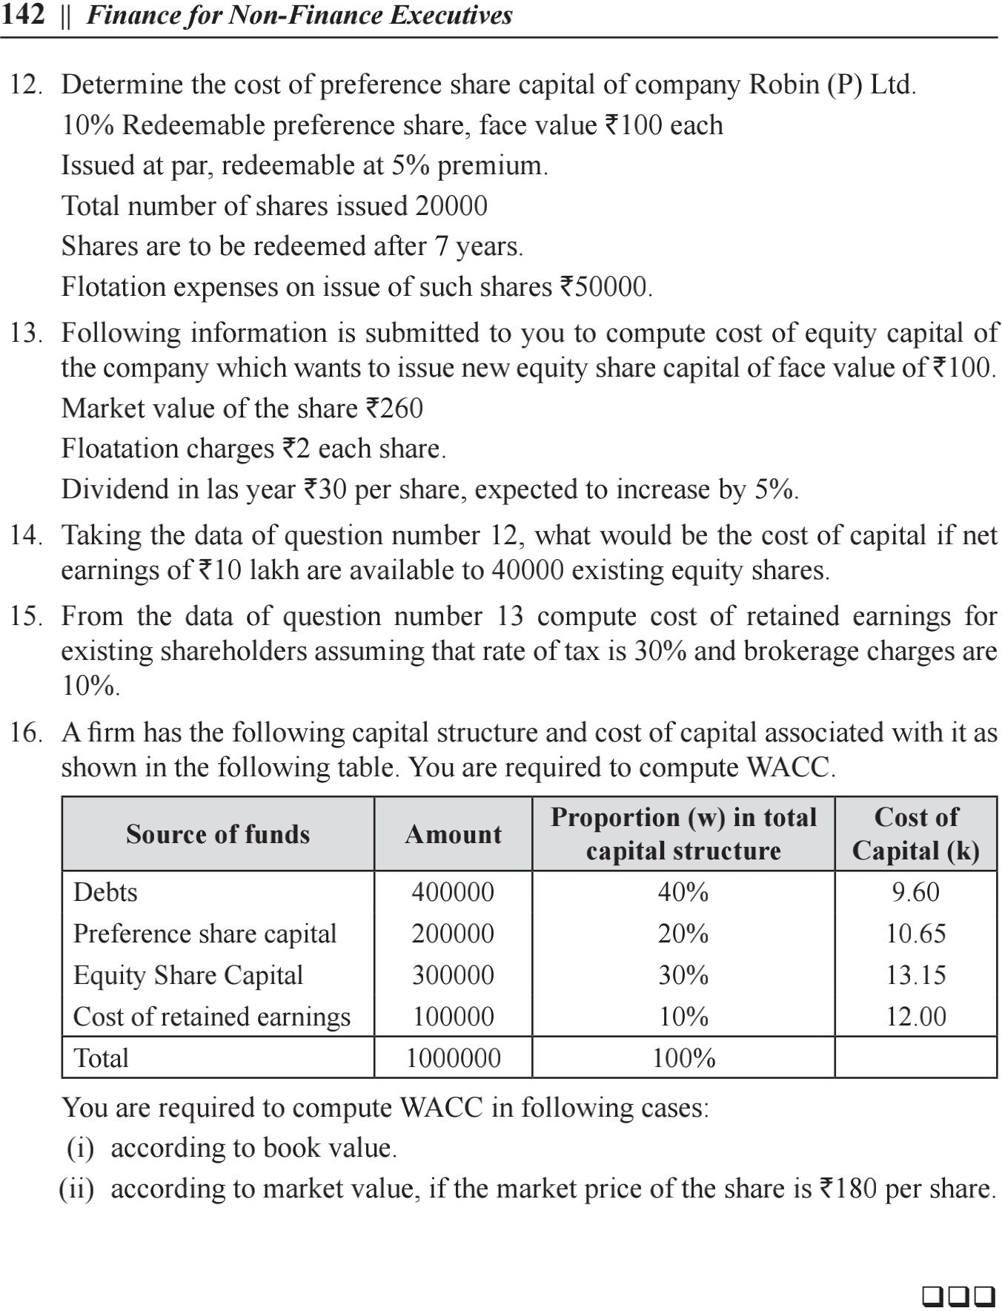



**CAPITAL STRUCTURE**

**MODULE IV**

Leverage means action of or way of applying lever. The functions of lever is raised a heavy object with a minimum force. In financial management, the term ‘leverage’ is used to describe the ability of a firm in employing long-term funds having a fixed cost to enhance the return to its owners i.e. equity shareholders. These fixed costs/returns may be assumed as the fulcrum of a lever. The presence of fixed cost has considerable influence on the earnings available to equity shareholders when the volume of output or sales is increased. Larger the presence of fixed costs higher is the leverage. If a firm is not required to pay fixed cost or fixed return, there will be no leverage.

According to **Soloman Ezra**, “Leverage is the ratio of the net rate of return on shareholders’ equity and the net rate of return on total capitalisation.”

According to **James E. Walter**, “Leverage may be defined as percentage return on equity to percentage return on capitalisation”.

According to **Weston and Brigham**, “In general usage, the leverage is defined as the ratio of total debt to total assets.”

According to **S.C. Kuchhal**, “Leverage may be defined as meeting a fixed cost or paying a fixed return for employing resources or funds.”

**Operating leverage**

Operating leverage measures a company’s fixed costs as a percentage of its total costs. It is used to evaluate the breakeven point of a business, as well as the likely profit levels on individual sales. The following two scenarios describe an organization having high operating leverage and low operating leverage.

High Operating Leverage

In a high operating leverage situation, a large proportion of the company’s costs are fixed costs. In this case, the firm earns a large profit on each incremental sale, but must attain sufficient sales volume to cover its substantial fixed costs. If it can do so, then the entity will earn a major profit on all sales after it has paid for its fixed costs. However, earnings will be more sensitive to changes in sales volume.

Low Operating Leverage

In a low operating leverage situation, a large proportion of the company’s sales are variable costs, so it only incurs these costs when there is a sale. In this case, the firm earns a smaller profit on each incremental sale, but does not have to generate much sales volume in order to cover its lower fixed costs. It is easier for this type of company to earn a profit at low sales levels, but it does not earn outsized profits if it can generate additional sales.

**Financial leverage**

Financial leverage is the use of debt to buy more assets. Leverage is employed to increase the return on equity. However, an excessive amount of financial leverage increases the risk of failure, since it becomes more difficult to repay debt.

The financial leverage formula is measured as the ratio of total debt to total assets. As the proportion of debt to assets increases, so too does the amount of financial leverage. Financial leverage is favorable when the uses to which debt can be put generate returns greater than the interest expense associated with the debt. Many companies use financial leverage rather than acquiring more equity capital, which could reduce the earnings per share of existing shareholders.

Advantages of Financial Leverage

Financial leverage has two primary advantages First, it can enhance earnings as a percentage of its assets. Second, interest expense is tax deductible in many tax jurisdictions, which reduces the net cost of debt to the borrower.

Disadvantages of Financial Leverage

Financial leverage also presents the possibility of disproportionate losses, since the related amount of interest expense may overwhelm the borrower if it does not earn sufficient returns to offset the interest expense. This is a particular problem when interest rates rise or the returns from assets decline.

|  |  |  |
| --- | --- | --- |
| **BASIS FOR COMPARISON** | **OPERATING LEVERAGE** | **FINANCIAL LEVERAGE** |
| Meaning | Use of such assets in the company's operations for which it has to pay fixed costs is known as Operating Leverage. | Use of debt in a company's capital structure for which it has to pay interest expenses is known as Financial Leverage. |
| Measures | Effect of Fixed operating costs. | Effect of Interest expenses |
| Relates | Sales and EBIT | EBIT and EPS |
| Ascertained by | Company's Cost Structure | Company's Capital Structure |
| Preferable | Low | High, only when ROCE is higher |
| Formula | DOL = Contribution / EBIT | DFL = EBIT / EBT |
| Risk | It give rise to business risk. | It give rise to financial risk. |

**Capital Structure**

The most crucial component of starting a business is capital. It acts as the foundation of the company. Debt and Equity are the two primary types of capital sources for a business. Capital structure is defined as the combination of equity and debt that is put into use by a company in order to finance the overall operations of the company and for its growth.

## Types of Capital Structure

The meaning of [Capital structure](https://byjus.com/commerce/mcqs-on-capital-structure/) can be described as the arrangement of capital by using different sources of long term funds which consists of two broad types, equity and debt. The different types of funds that are raised by a firm include preference shares, equity shares, retained earnings, long-term loans etc. These funds are raised for running the business.

### **Equity Capital**

Equity capital is the money owned by the shareholders or owners. It consists of two different types

a) [Retained earnings](https://byjus.com/commerce/retained-earnings/): Retained earnings are part of the profit that has been kept separately by the organisation and which will help in strengthening the business.

b) Contributed Capital: Contributed capital is the amount of money which the company owners have invested at the time of opening the company or received from shareholders as a price for ownership of the company.

### **Debt Capital**

Debt capital is referred to as the borrowed money that is utilised in business. There are different forms of debt capital.

1. Long Term Bonds: These types of bonds are considered the safest of the debts as they have an extended repayment period, and only interest needs to be repaid while the principal needs to be paid at maturity.
2. Short Term Commercial Paper: This is a type of short term debt instrument that is used by companies to raise capital for a short period of time

### **Optimal Capital Structure**

Optimal capital structure is referred to as the perfect mix of debt and equity financing that helps in maximising the value of a company in the market while at the same time minimises its cost of capital.

Capital structure varies across industries. For a company involved in mining or petroleum and oil extraction, a high debt ratio is not suitable, but some industries like insurance or banking have a high amount of debt as part of their capital structure.

### **Financial Leverage**

Financial leverage is defined as the proportion of debt that is part of the total capital of the firm. It is also known as capital gearing. A firm having a high level of debt is called a highly levered firm while a firm having a lower ratio of debt is known as a low levered firm.

### **Importance of Capital Structure**

Capital structure is vital for a firm as it determines the overall stability of a firm. Here are some of the other factors that highlight the importance of capital structure

1. A firm having a sound capital structure has a higher chance of increasing the market price of the shares and securities that it possesses. It will lead to a higher valuation in the market.
2. A good capital structure ensures that the available funds are used effectively. It prevents over or under capitalisation.
3. It helps the company in increasing its profits in the form of higher returns to stakeholders.
4. A proper capital structure helps in maximising shareholder’s capital while minimising the overall cost of the capital.
5. A good capital structure provides firms with the flexibility of increasing or decreasing the debt capital as per the situation.

## Factors Determining Capital Structure

Following are the factors that play an important role in determining the capital structure:

1. Costs of capital: It is the cost that is incurred in raising capital from different fund sources. A firm or a business should generate sufficient revenue so that the cost of capital can be met and growth can be financed.
2. Degree of Control: The equity shareholders have more rights in a company than the preference shareholders or the debenture shareholders. The capital structure of a firm will be determined by the type of shareholders and the limit of their voting rights.
3. Trading on Equity: For a firm which uses more equity as a source of finance to borrow new funds to increase returns. Trading on equity is said to occur when the rate of return on total capital is more than the rate of interest paid on debentures or rate of interest on the new debt borrowed.
4. Government Policies: The capital structure is also impacted by the rules and policies set by the government. Changes in monetary and fiscal policies result in bringing about changes in capital structure decisions.

Net Income Approach

Net income (NI) approach as this is also called as traditional approach. This is an approach in which both cost of debt, and equity are independent of capital structure. The components which are involved in it are constant and doesn't depend on how much debt the firm is using. This theory was proposed by David Durand. In this change in financial leverage leads to change in overall cost of capital as well as total value of firm. If financial leverage increases, weighted average cost decreases and value of firm and market price of equity increases. If this decreases then weighted average cost of capital increases and value of firm and market price of equity decreases. The assumptions which can be made according to this approach is that there are no taxes involved in this and the use of debt doesn't change the risk factor for the investors and will remain the same throughout.

Assumptions

* The increase in debt will not affect the confidence levels of the investors.
* There are only two sources of finance; debt and equity. There are no sources of finance like Prefrence Share Capital and Retained Earning.
* All companies have uniform dividend pay out ratio; it is 1.
* There is no [flotation cost, no transaction cost and corporate dividend tax](https://efinancemanagement.com/sources-of-finance/flotation-cost).
* Capital market is perfect, it means information about all companies are available to all investors and there are no chances of over pricing or under pricing of security. Further it means that all investors are rational.

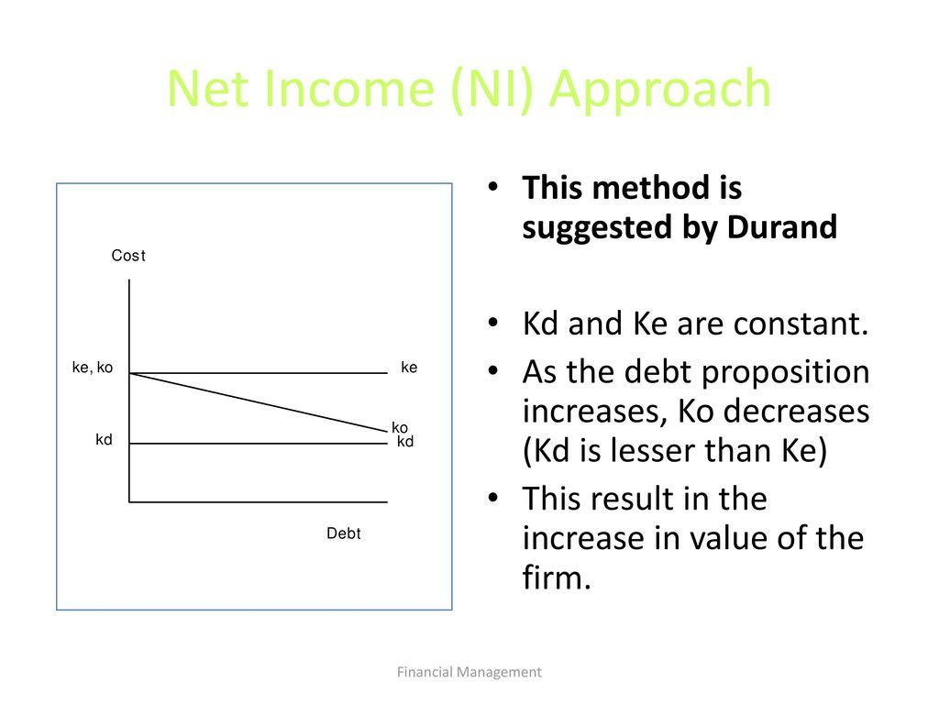

## Net Operating Income Approach (NOI Approach)

This approach was put forth by Durand and totally differs from the Net Income Approach. Also famous as traditional approach, Net Operating Income Approach suggests that change in debt of the firm/company or the change in leverage fails to affect the total value of the firm/company. As per this approach, the WACC and the total value of a company are independent of the [capital structure decision](https://efinancemanagement.com/financial-leverage/capital-structure-decisions) or financial leverage of a company. As per this approach, the market value is dependent on the operating income and the associated business risk of the firm. Both these factors cannot be impacted by the financial leverage. Financial leverage can only impact the share of income earned by debt holders and equity holders but cannot impact the operating incomes of the firm. Therefore, change in debt to equity ratio cannot make any change in the value of the firm. It further says that with the increase in the debt component of a company, the company is faced with higher risk. To compensate that, the equity shareholders expect more returns. Thus, with an increase in financial leverage, the cost of equity increases.

Assumptions:

* The overall capitalization rate remains constant irrespective of the degree of leverage. At a given level of EBIT, the value of the firm would be “EBIT/Overall capitalization rate”
* Value of equity is the difference between total firm value less value of debt i.e. Value of Equity = Total Value of the Firm – Value of Debt
* WACC (Weightage Average Cost of Capital) remains constant; and with the increase in debt, the cost of equity increases. An increase in debt in the [capital structure](https://efinancemanagement.com/financial-leverage/factors-affecting-capital-structure-decision) results in increased risk for shareholders. As a compensation of investing in the highly leveraged company, the shareholders expect higher return resulting in higher cost of equity capital.

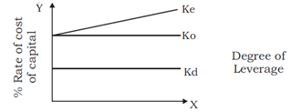

## The Traditional Approach

The traditional approach to capital structure stresses the fact that there is a right mix of equity and debt in the capital structure, at which the market value of a company is maximum.

* This approach tells that in the capital structure of a company, debt should exist in the capital structure only up to a specific point. Beyond this point, any increase in leverage would result in a reduction in the value of the firm.
* In other words, it means that there is an optimum value of debt-to-equity ratio at which the Weighted Average Cost of Capital (WACC) is the lowest, while the market value of the firm is the highest.
* After the specific debt to equity ratio, the cost of equity goes up to offer a detrimental effect to the WACC. When the debt-to-equity ratio goes above the threshold, the WACC goes up and the market value of the firm starts to go down.

## Assumptions

* The rate of interest on the debt stays constant for a certain period and after that, with an increase in leverage, it goes up.
* The expected rate of interest in investment by equity shareholders remains constant or increases gradually. After reaching the threshold, the equity shareholders start perceiving a financial risk, and then from the optimal point, the expected rate of interest increases quickly.
* As a result of the rate of interest and expected rate of return working together, the WACC first starts to decrease, and then it increases. In the capital structure graph, the lowest point refers to the optimal ratio.

An increase or decline in the optimal structure of capital affects the value of a firm. Hence, when the overall cost of capital is diminished up to a specific level of debt, the optimal capital structure comes into effect to increase the value of a company.

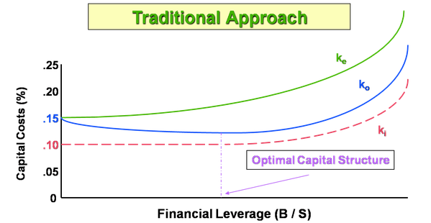

**Modigliani and Miller Approach**

This approach was devised by Modigliani and Miller during the 1950s. The fundamentals of the Modigliani and Miller Approach resemble that of the Net Operating Income Approach. Modigliani and Miller advocate capital structure irrelevancy theory, which suggests that the valuation of a firm is irrelevant to the capital structure of a company. Whether a firm is high on leverage or has a lower debt component in the financing mix has no bearing on the value of a firm. The Modigliani and Miller Approach further state that the operating income affects the market value of the firm, apart from the risk involved in the investment. The theory stated that the value of the firm is not dependent on the choice of [capital structure or financing decisions](https://efinancemanagement.com/financial-leverage/capital-structure-decisions) of the firm.

## Assumptions

* There are no taxes.
* Transaction cost for buying and selling securities, as well as the bankruptcy cost, is nil.
* There is a symmetry of information. This means that an investor will have access to the same information that a corporation would and investors will thus behave rationally.
* The cost of borrowing is the same for investors and companies.
* There is no floatation cost, such as an underwriting commission, payment to merchant bankers, advertisement expenses, etc.
* There is no corporate dividend tax.

The Modigliani and Miller Approach indicates that the value of a leveraged firm (a firm that has a mix of debt and equity) is the same as the value of an unleveraged firm (a firm that is wholly financed by equity). If the operating profits and future prospects are the same. That is, if an investor purchases shares of a leveraged firm, it would cost him the same as buying the shares of an unleveraged firm.

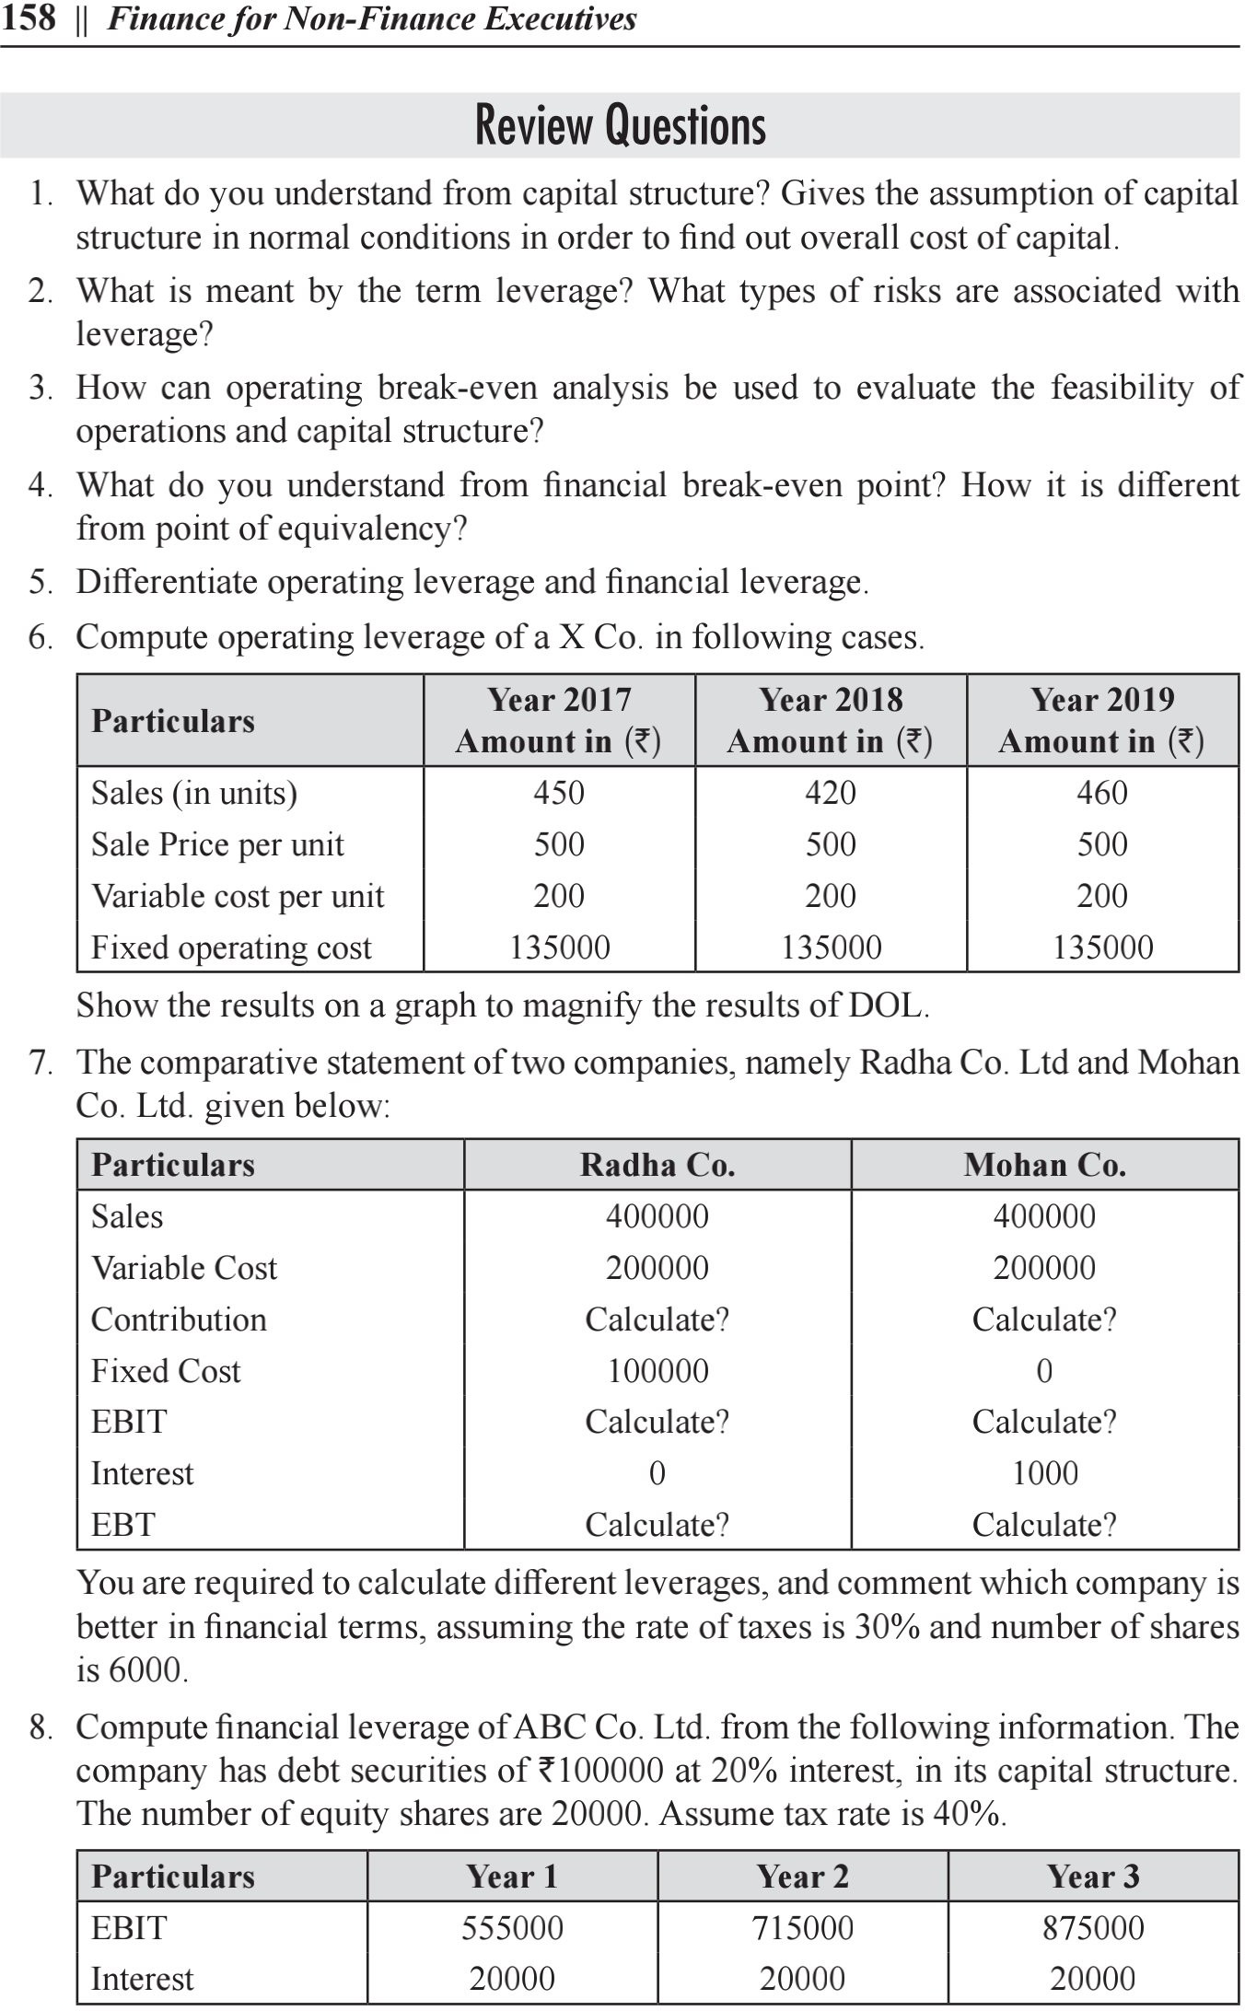

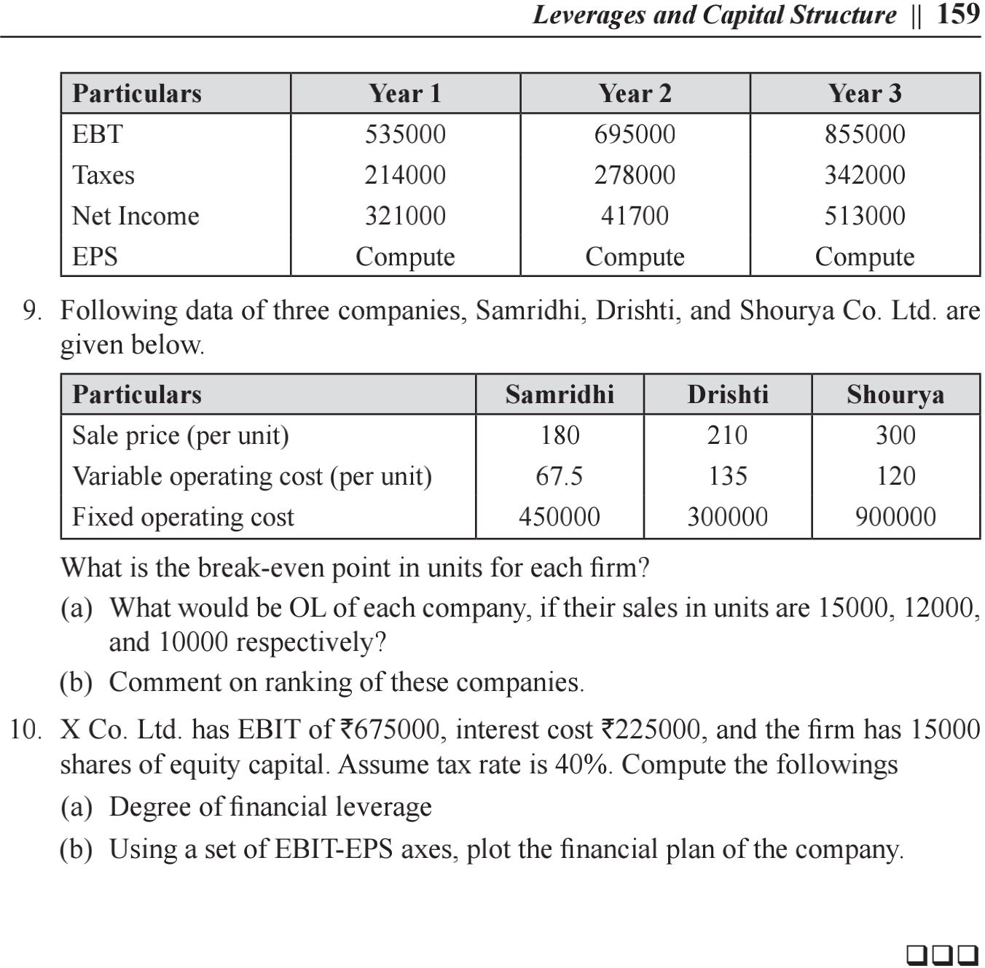

**FINANCIAL MANAGEMENT QUESTIONS**

1. What is the financial management?
2. Why financial management need for business?
3. What are the functions of financial management?
4. Define finance.
5. What are the objectives of financial management?
6. What is profit maximization?
7. What is wealth maximization?
8. What are the short term sources of finance?
9. What are the long term sources of finance?
10. Define shares.
11. Which factors affects financialdecisions. 12.Define cost of capital.
12. Define Equity.
13. What is preferred stock?
14. Define Weighted average cost of capital. 16.What is operating leverage?

17.Define financial leverage. 18.Define leverage.

19.Write any two advantages of leverage. 20.Write any two advantages of cost of capital,

1. What is meant by optimal capital structure? 22.List the factors influencing capital structure
   1. Give the meaning of dividend.
   2. Listout the determinants of dividend policy. 25.What are the major sources available for dividends? 26.List the classification of dividend.

27.What are the sources available for dividends? 28.Define general dividend policy.

29. Give the meaning of dividend policy. 30.Define capital structure.Define capital budgeting.

1. Write any two objectives of capital budgeting. 33.Explain capital budgeting decisions.

34.Write two types of capital budgeting. 35.Briefly explain methods of capital budgeting. 36.Expand ARR.

37.How do you calculate the ARR?

38.Expand IRR.

39.State the steps of capital budgeting process.

40.Write a note on internal rate of return.

**Summary**

Financial management practices is a field which deals with financial decisions including short and long goals of the organization and ensures that there is a high return on the invested capital without necessarily taking excess finance risk. Financial management is an essential discipline as it guides the financial managers to make informed financial decisions in their companies. Financial management is guided by several principles that the managers should adhere to in ensuring that the finances of a company are appropriately invested. The investment comes with the analysis of the outcome where different financial profitability and market ratios are used in establishing the stability of a firm.

Reference Books:

1. Van Horne, Bhaduri – Fundamentals of Financial Management- Pearson

2. I.M. Pandey, Financial Management, Vikash Publications.

3. Khan & Jain, Financial Management, Tata McGraw Hill